**Project Report**

**Title: Marketing Website**

## BACHELOR OF TECHNOLOGY

Computer Science and Engineering

Submitted to

## Ms. Nausheen Fatima

**LOVELY PROFESSIONAL UNIVERSITY PHAGWARA, PUNJAB**

**SUBMITTED BY :-Huda Usman** **Reg***.***No:-12207433** **Roll No:-**

70

# ACKNOWLEDGEMENT



In completing this project we have been fortunate enough to have support and encouragement from my group mates. I would like to acknowledge them for their cooperation. Firstly, I would like to thank my teacher Ms.NAUSHEEN FATIMA mam for making us learn new things and her thoughts have been a constant source of inspiration for us. We would also like to acknowledge the contribution of all faculty members of the Department for their kind assistance , suggestions and cooperation throughout the development of the project.

***DESIGN AND SOURCE CODE***

ABOUT US PAGE

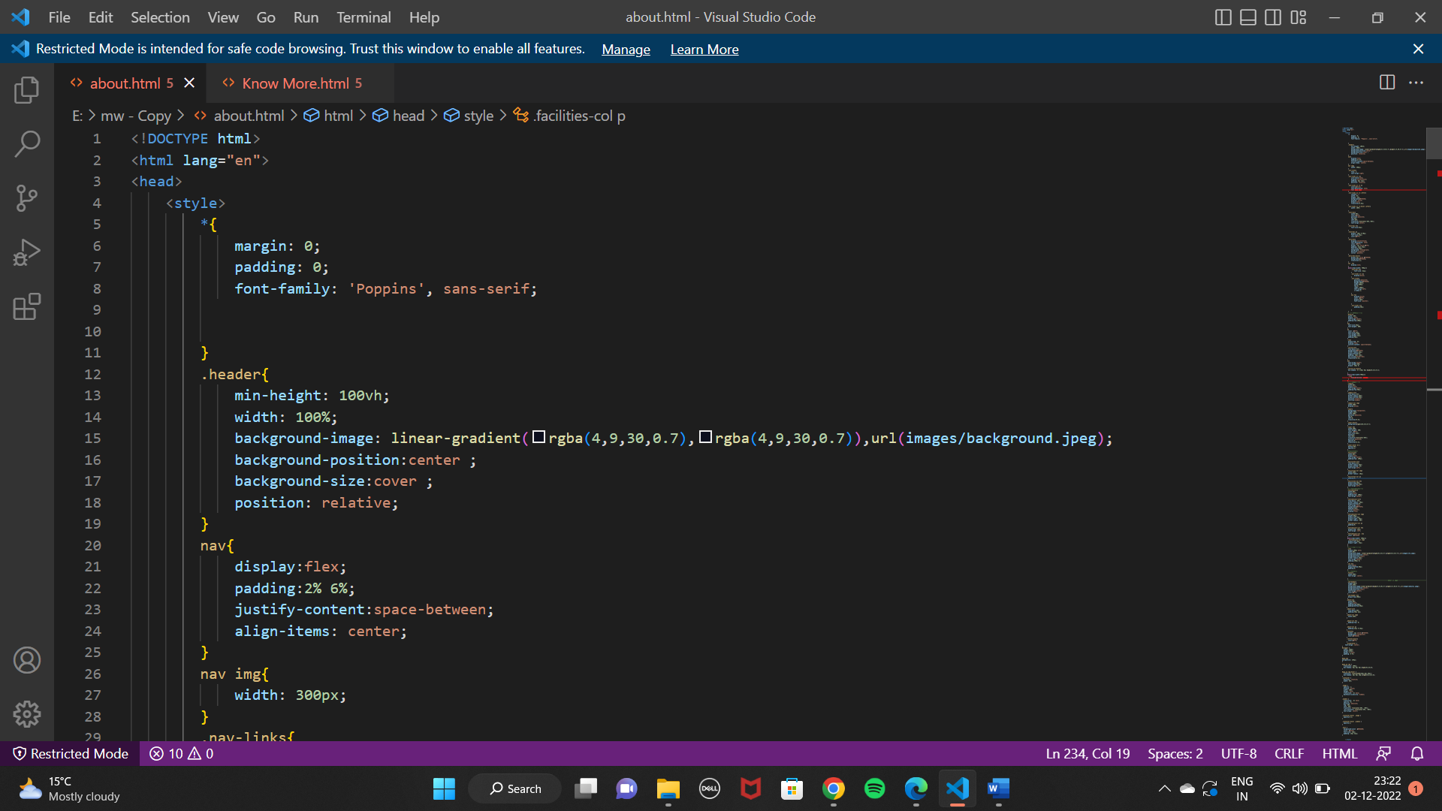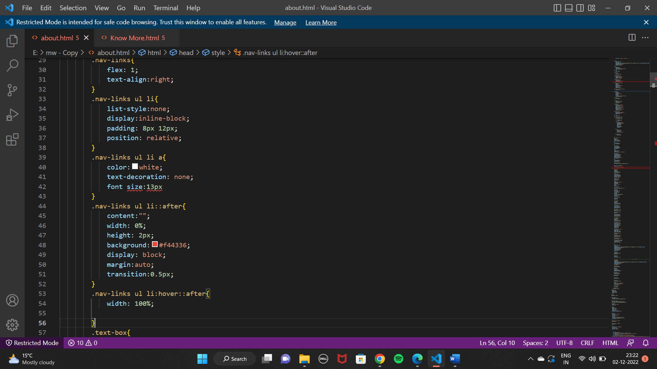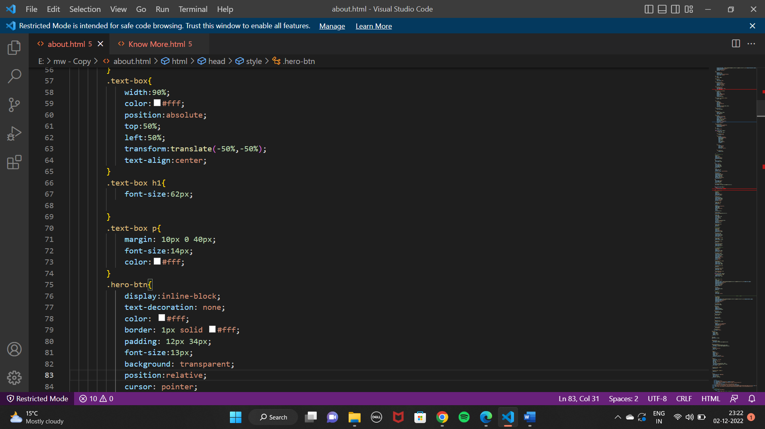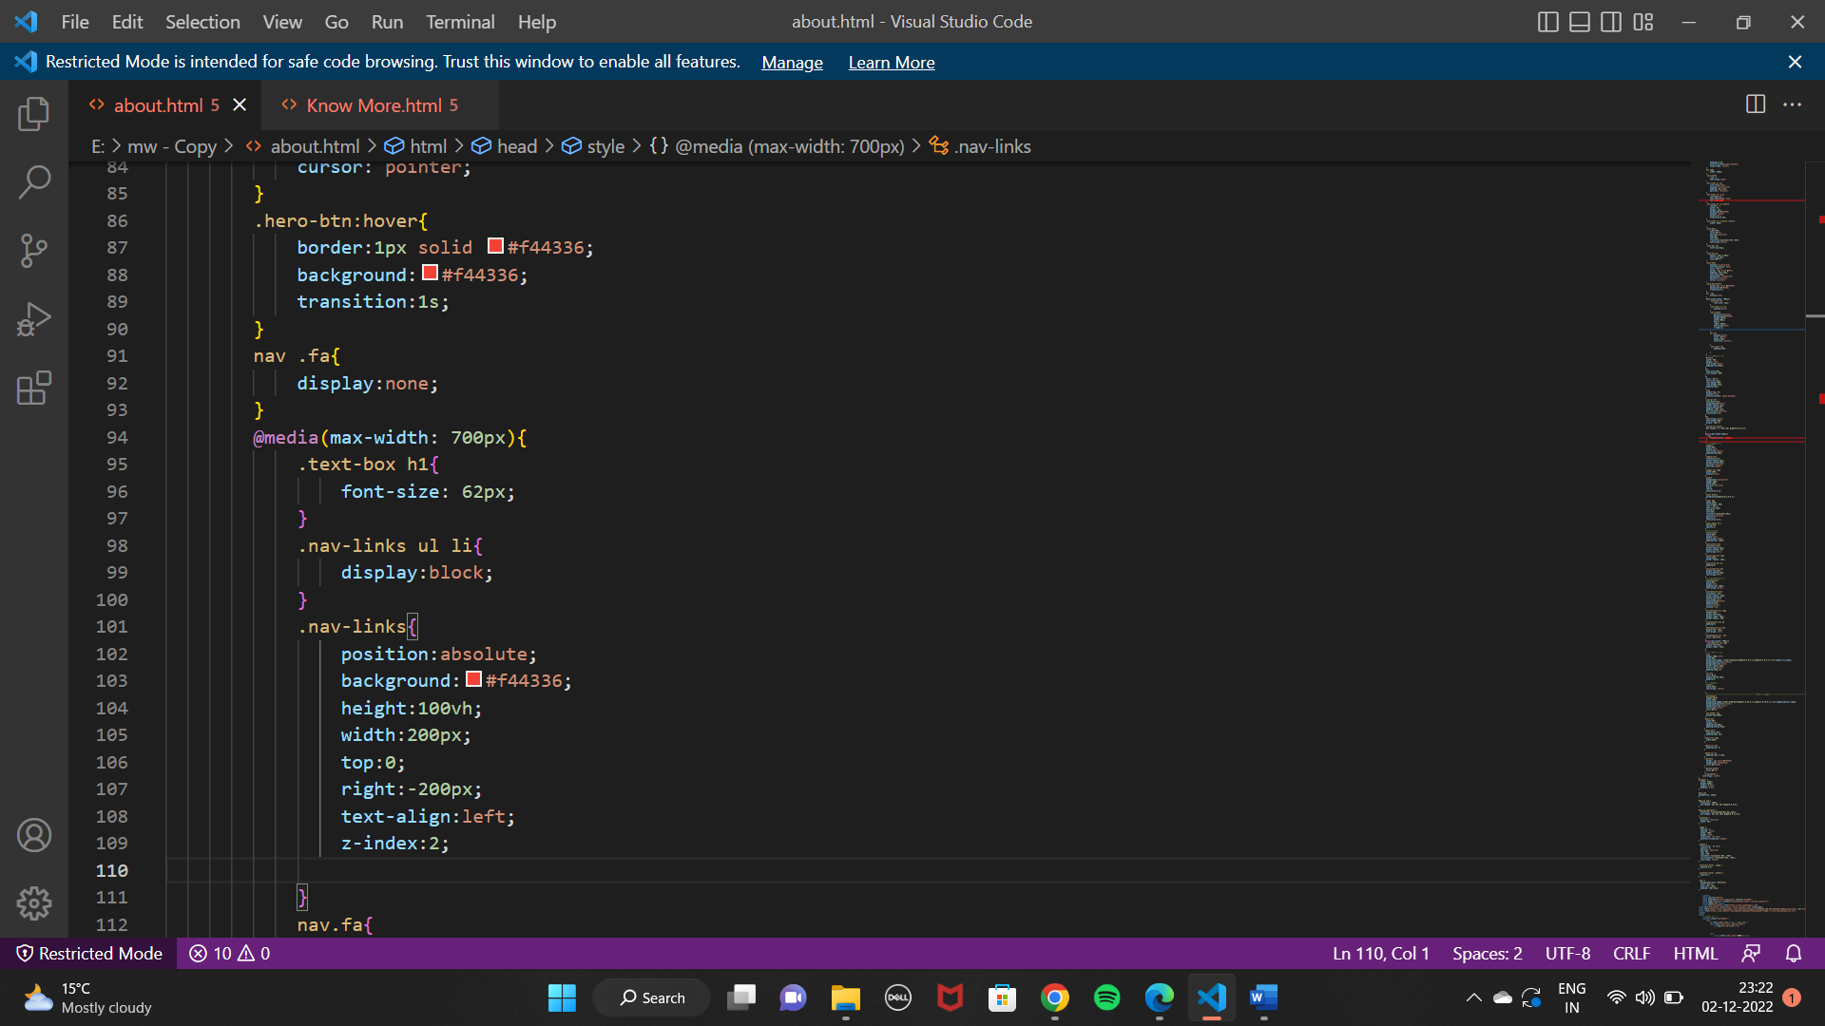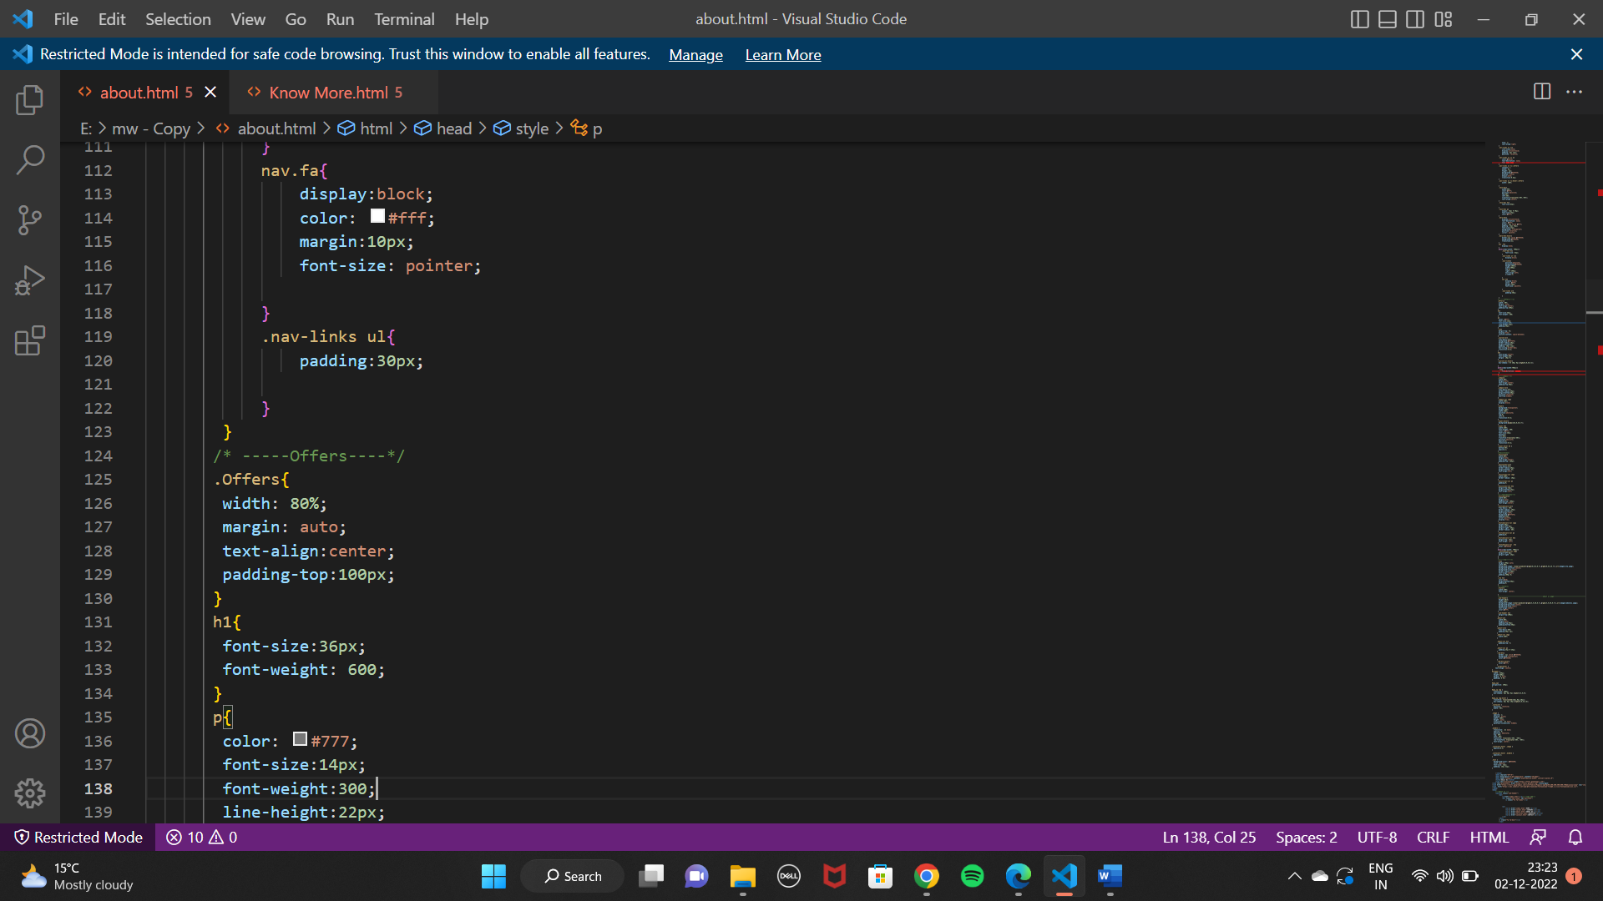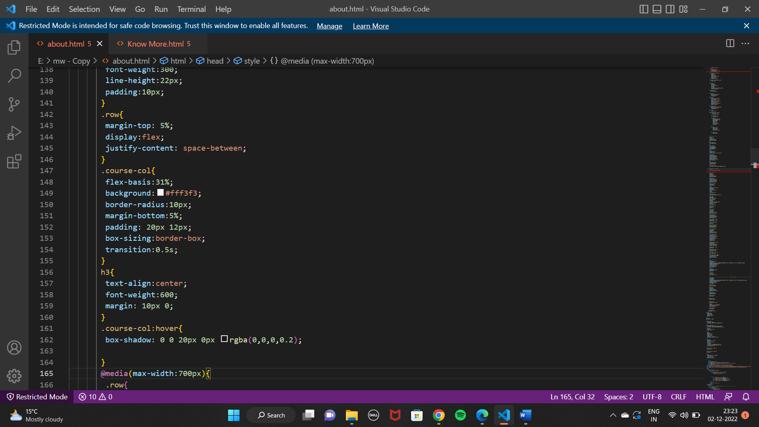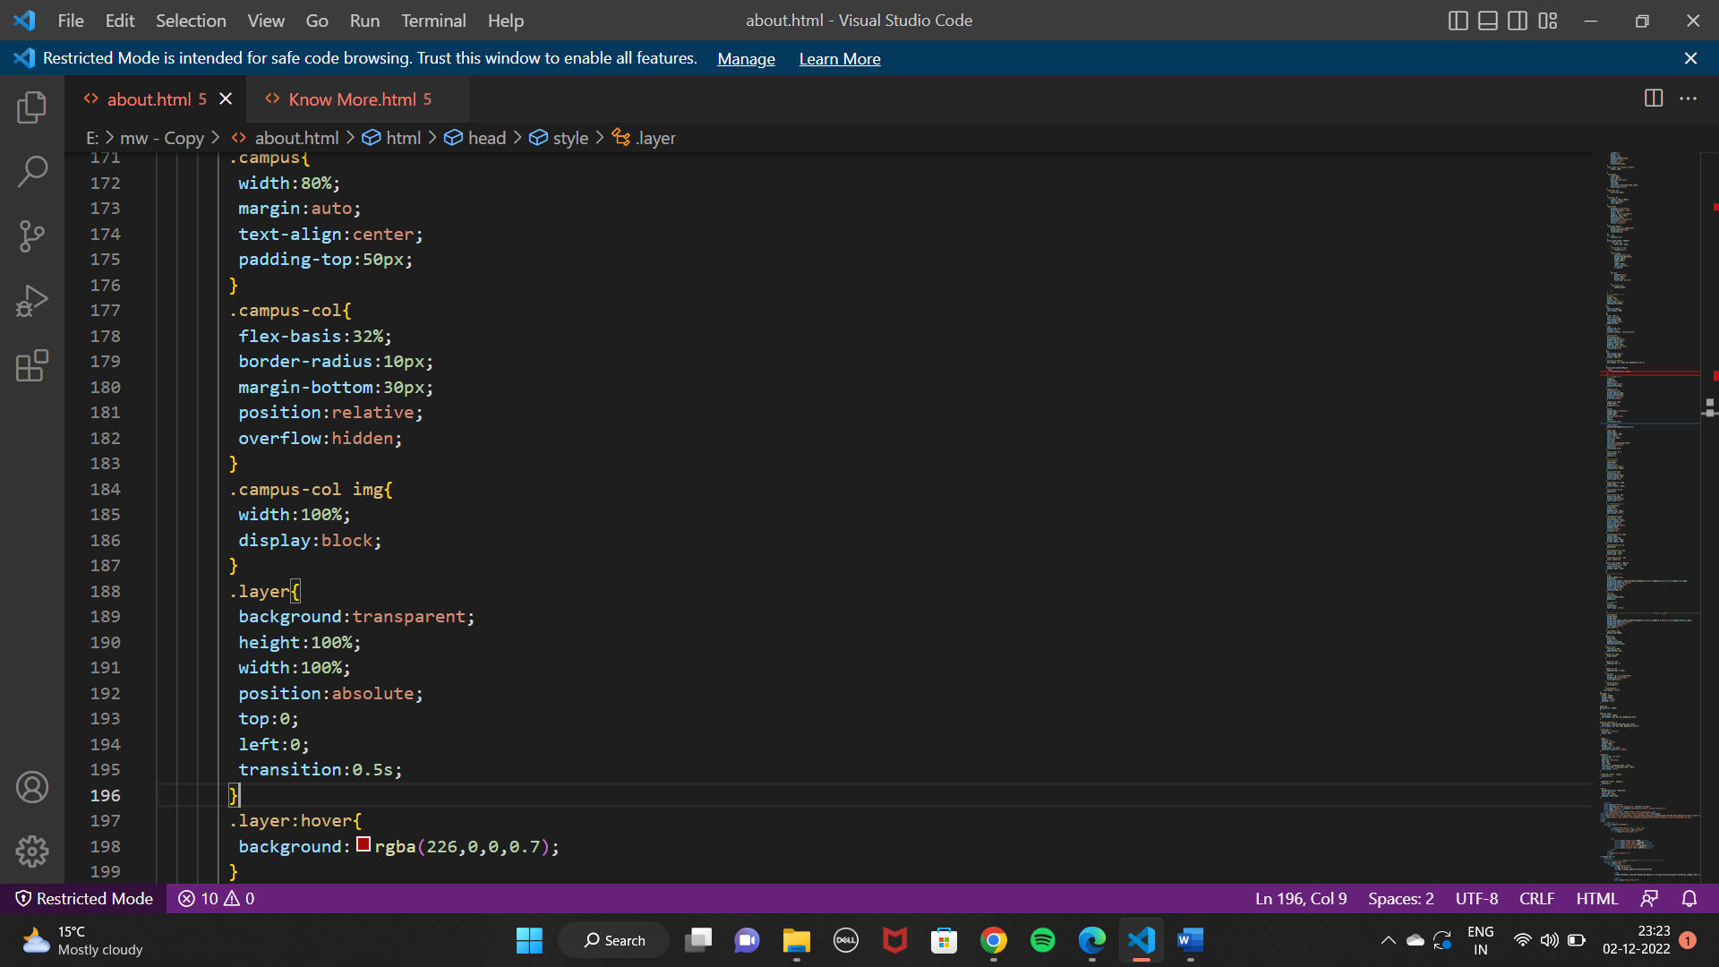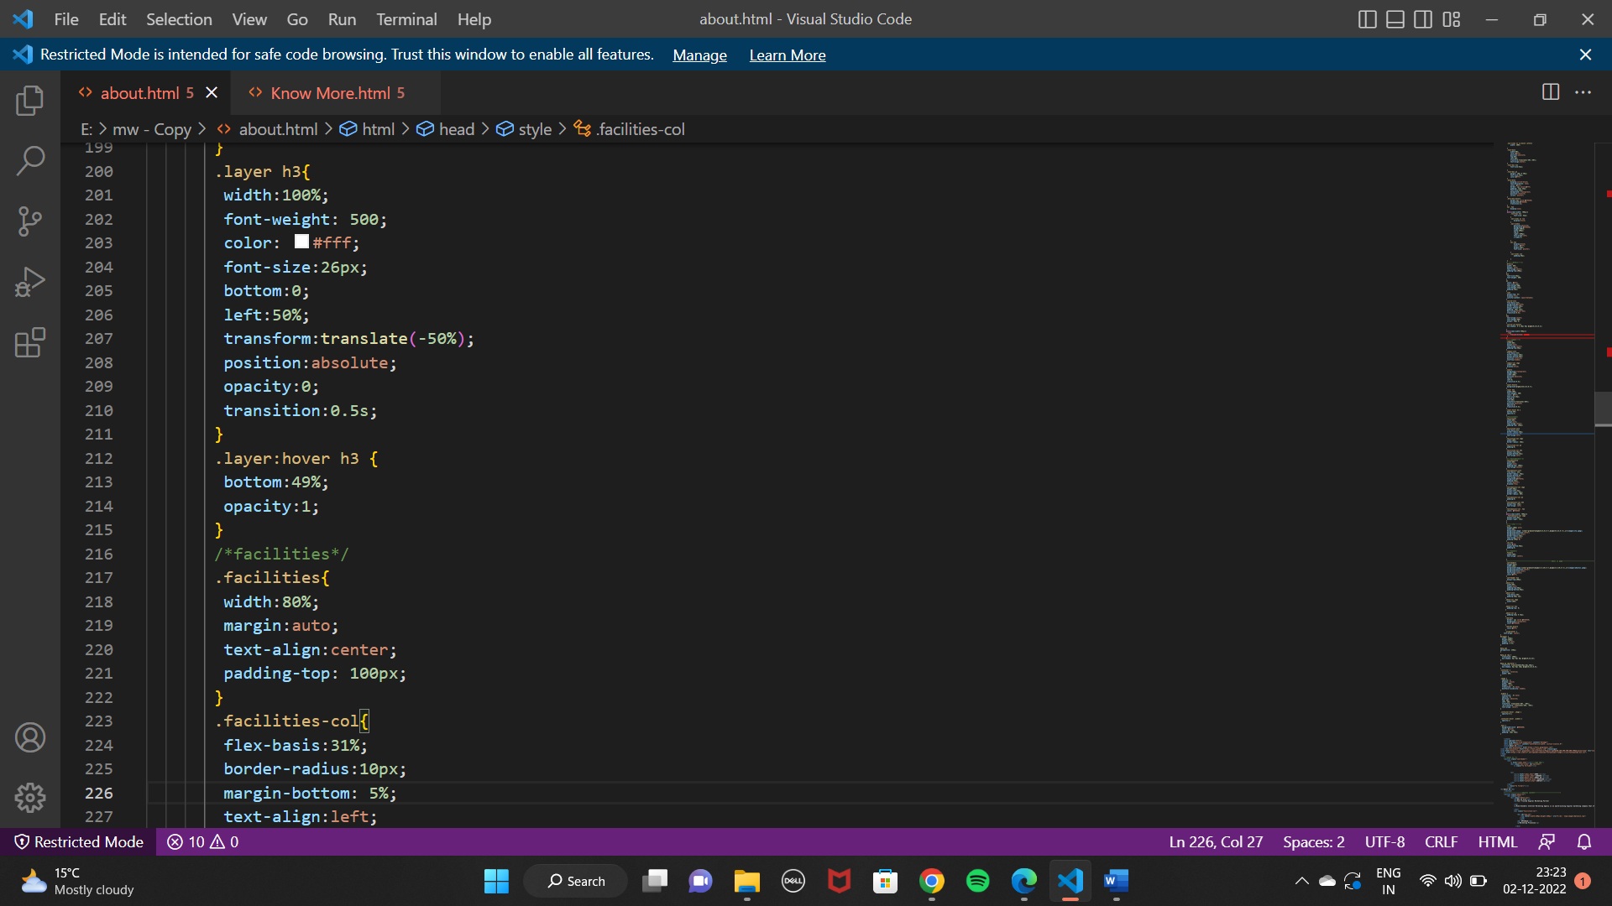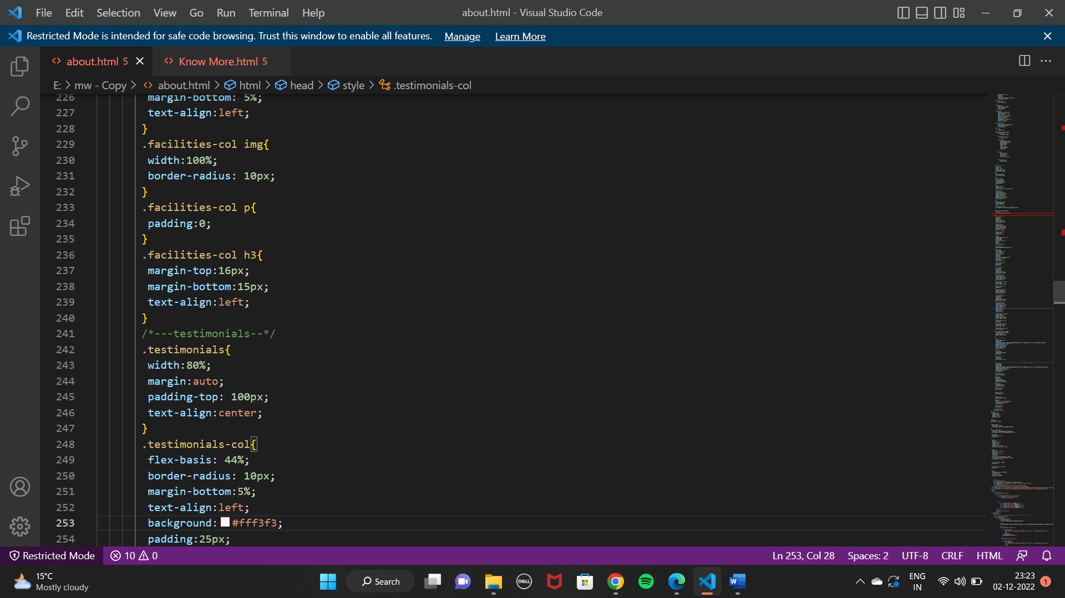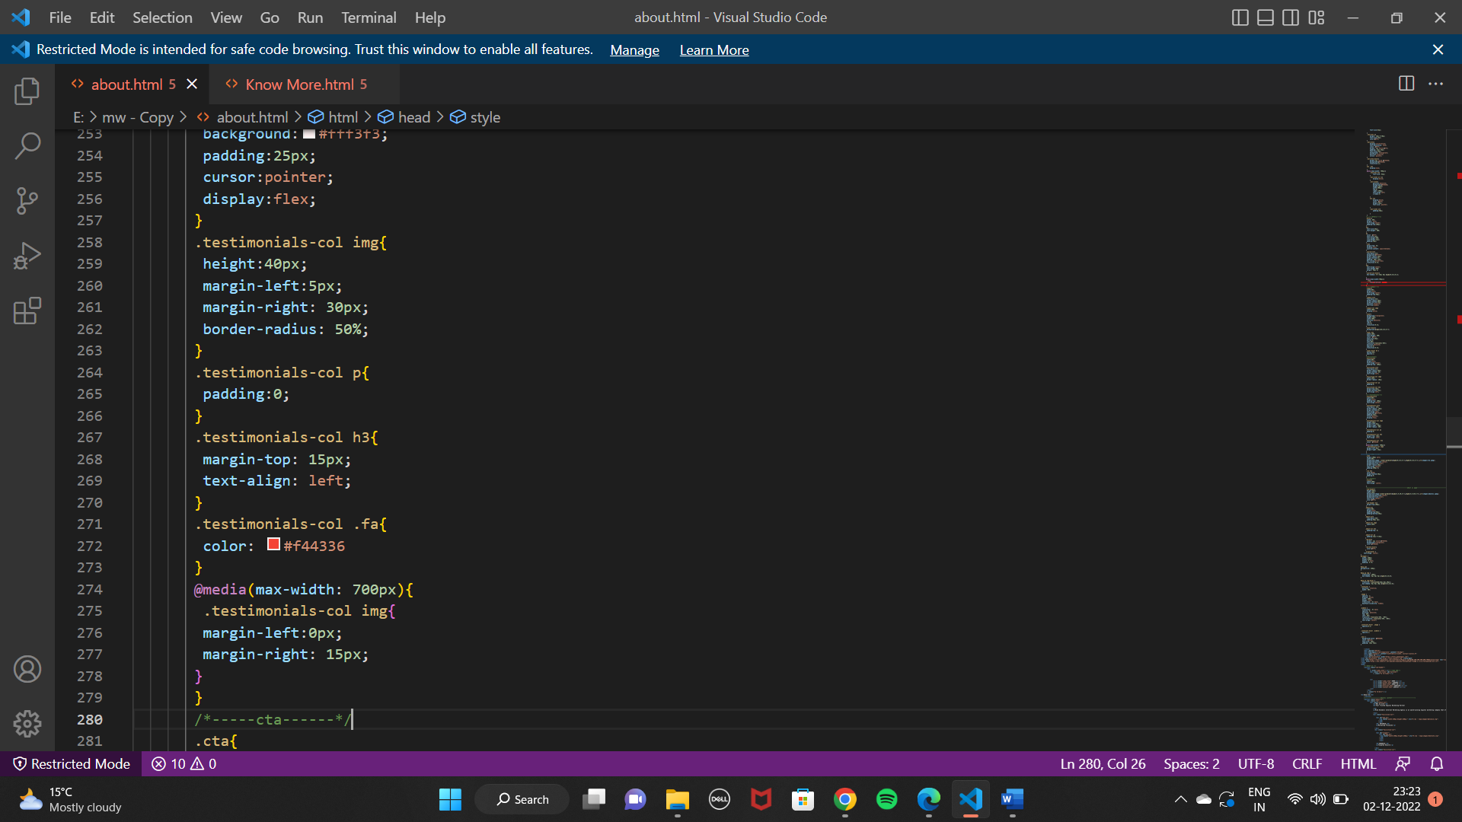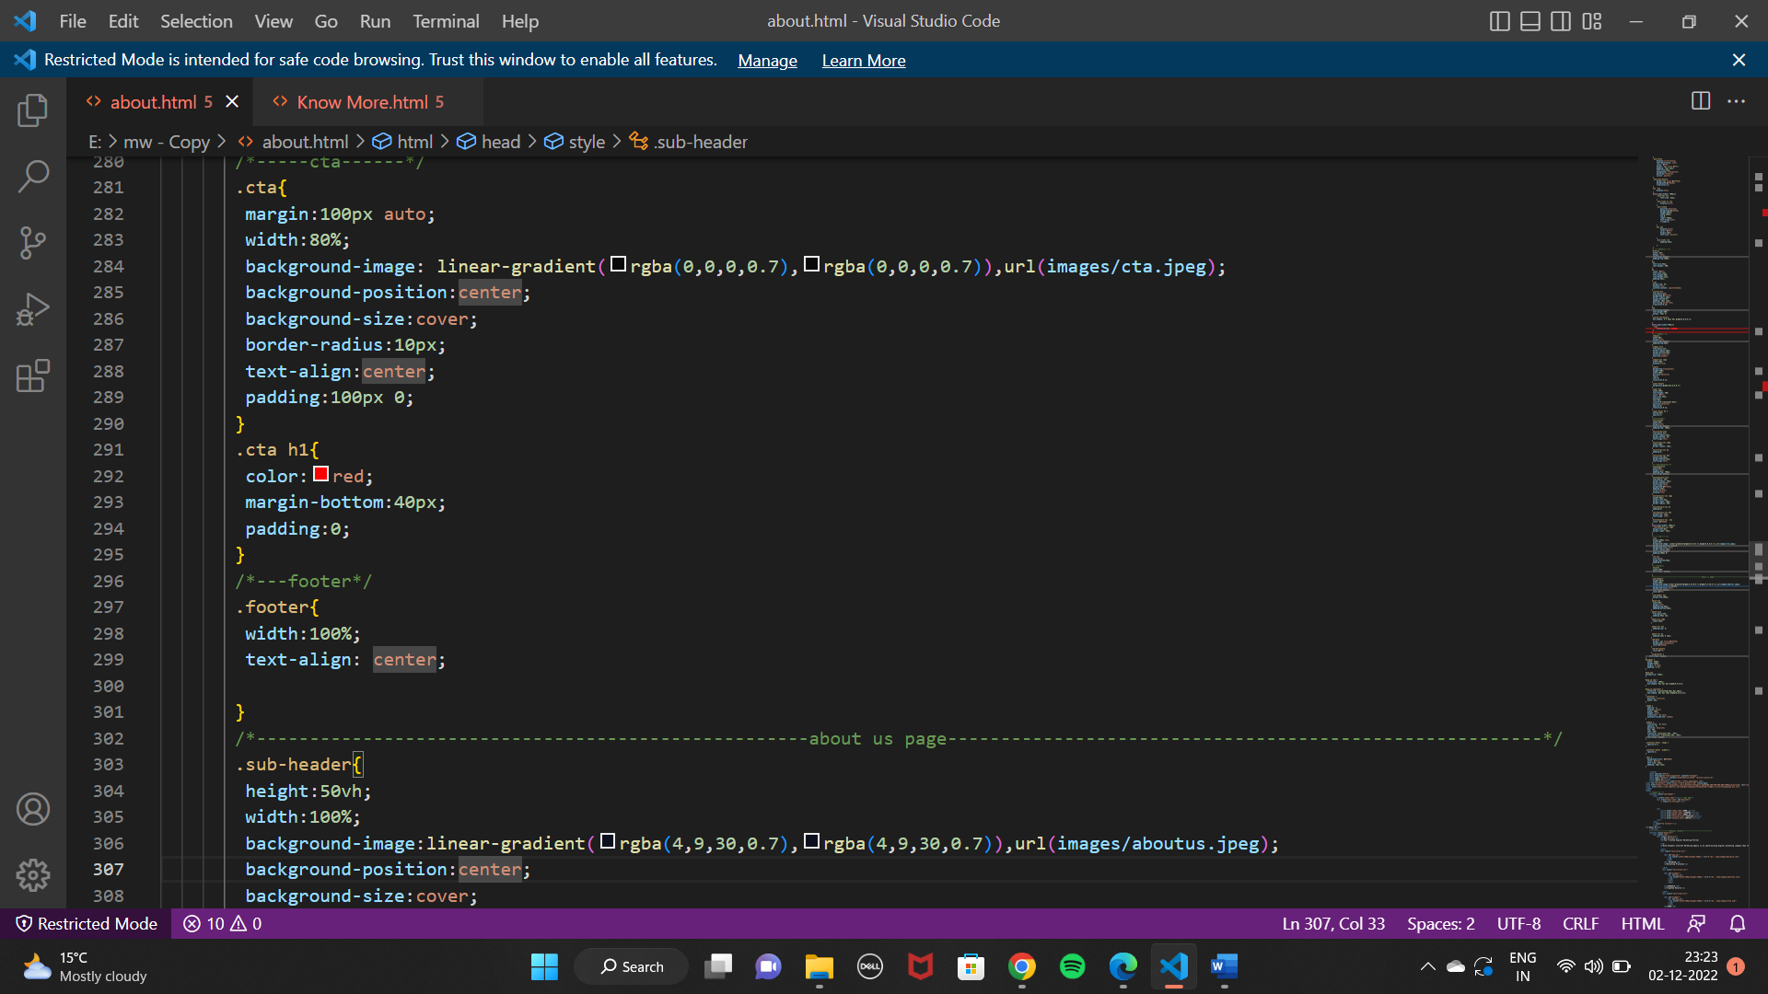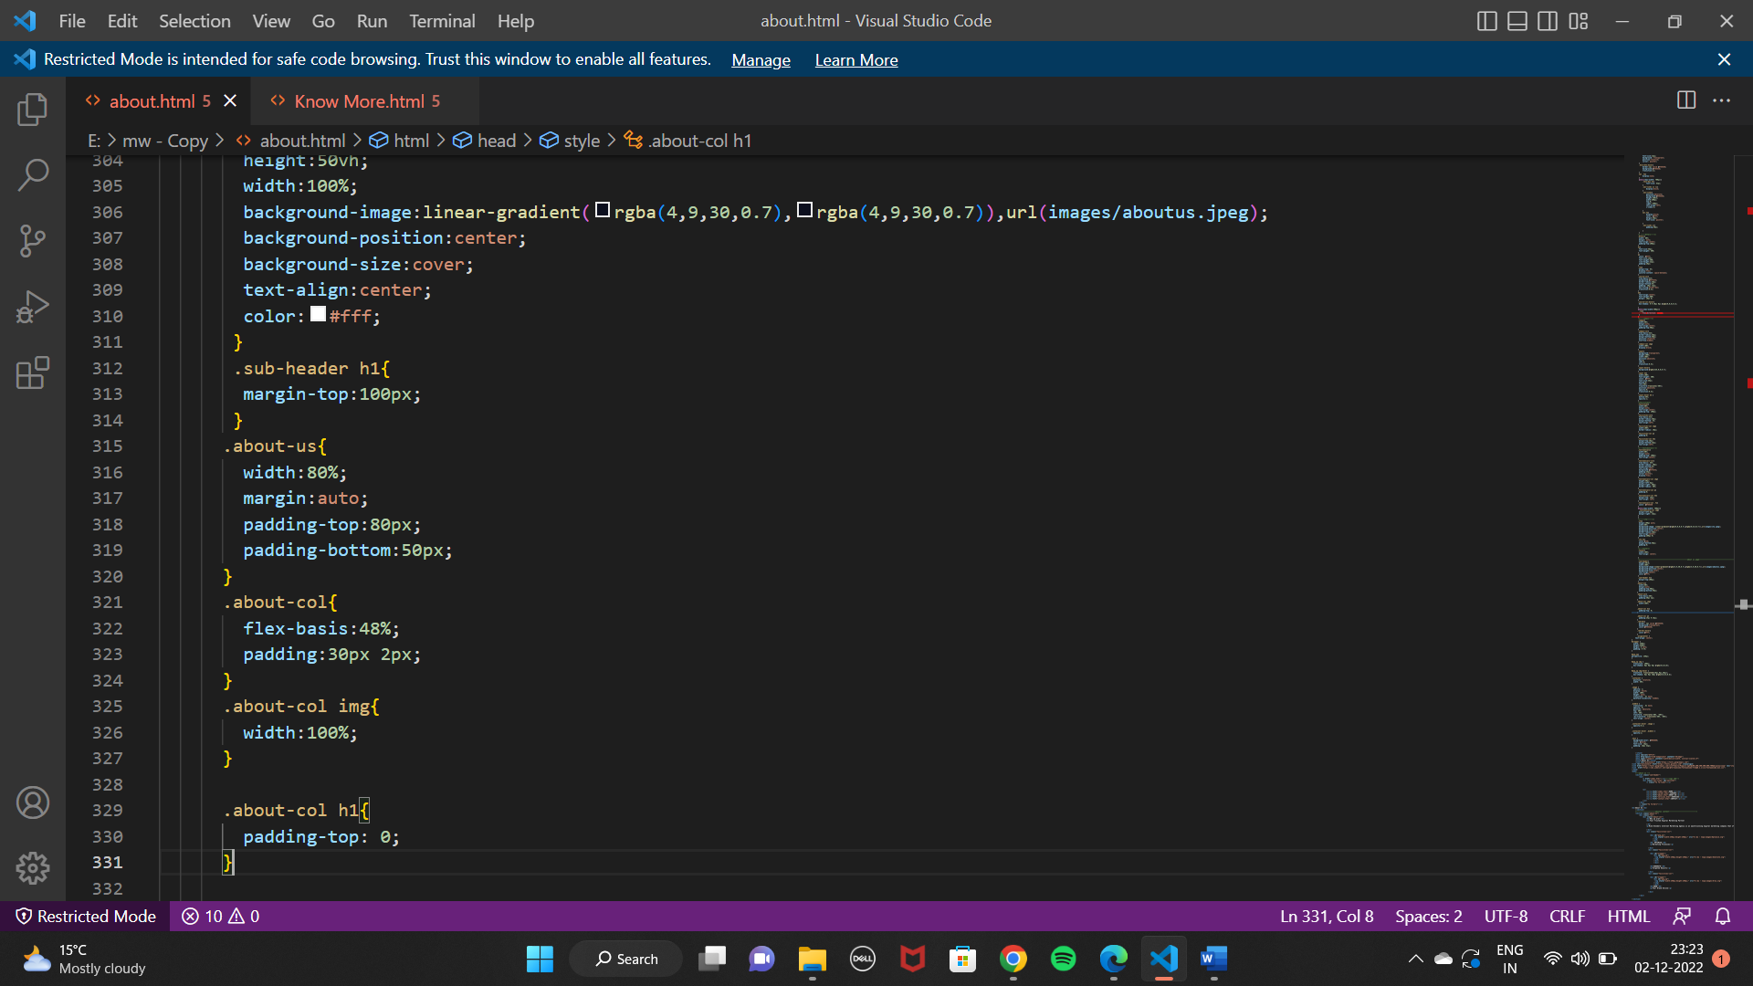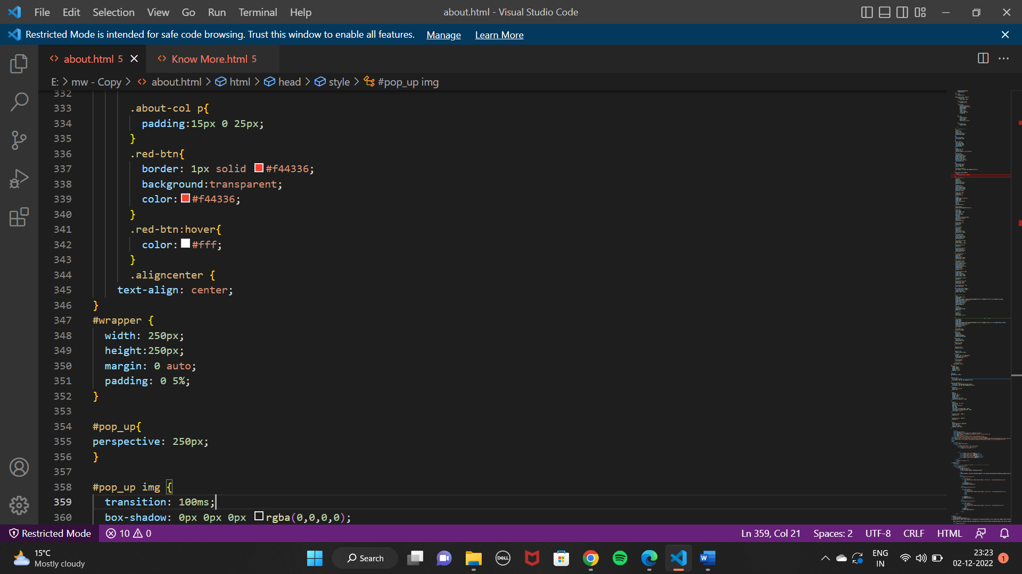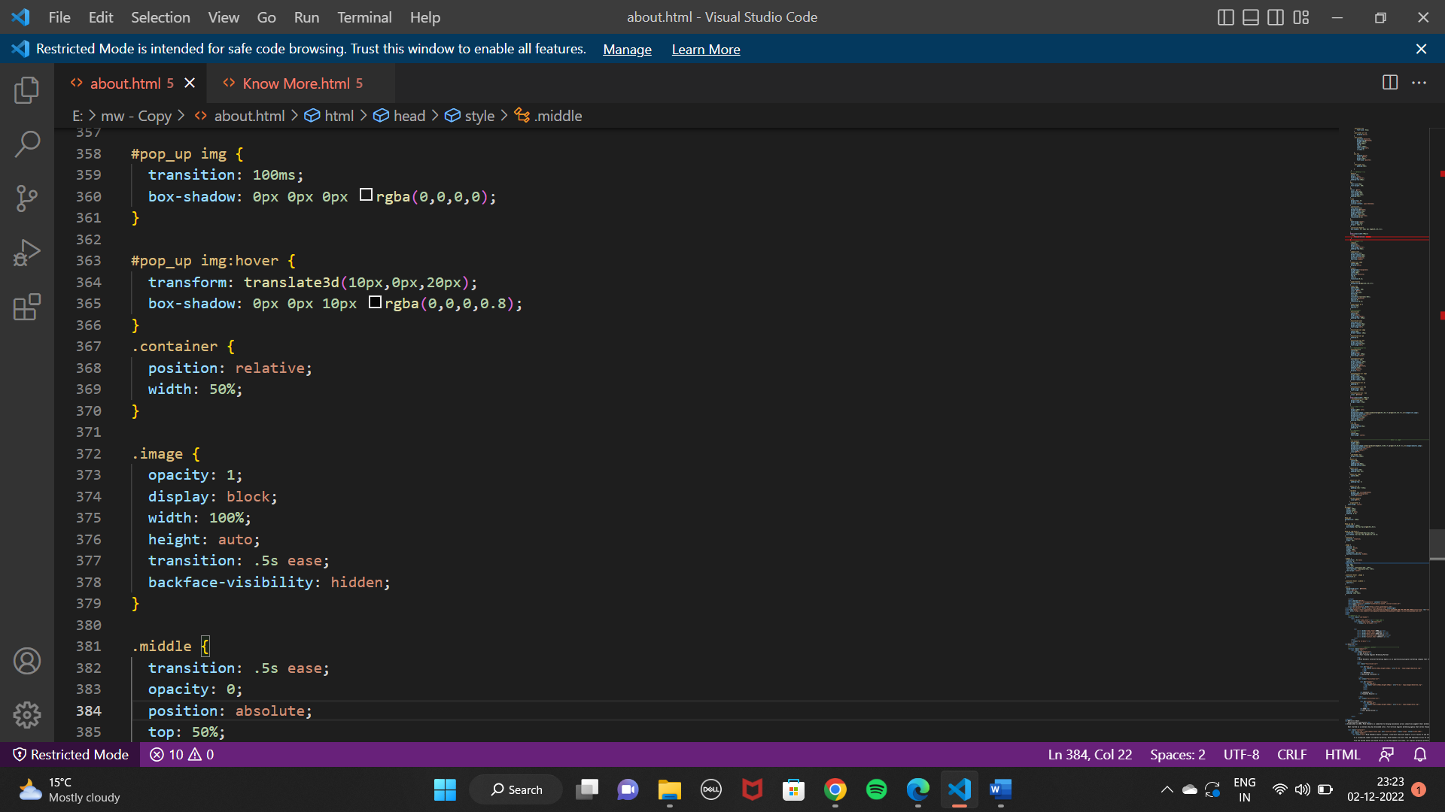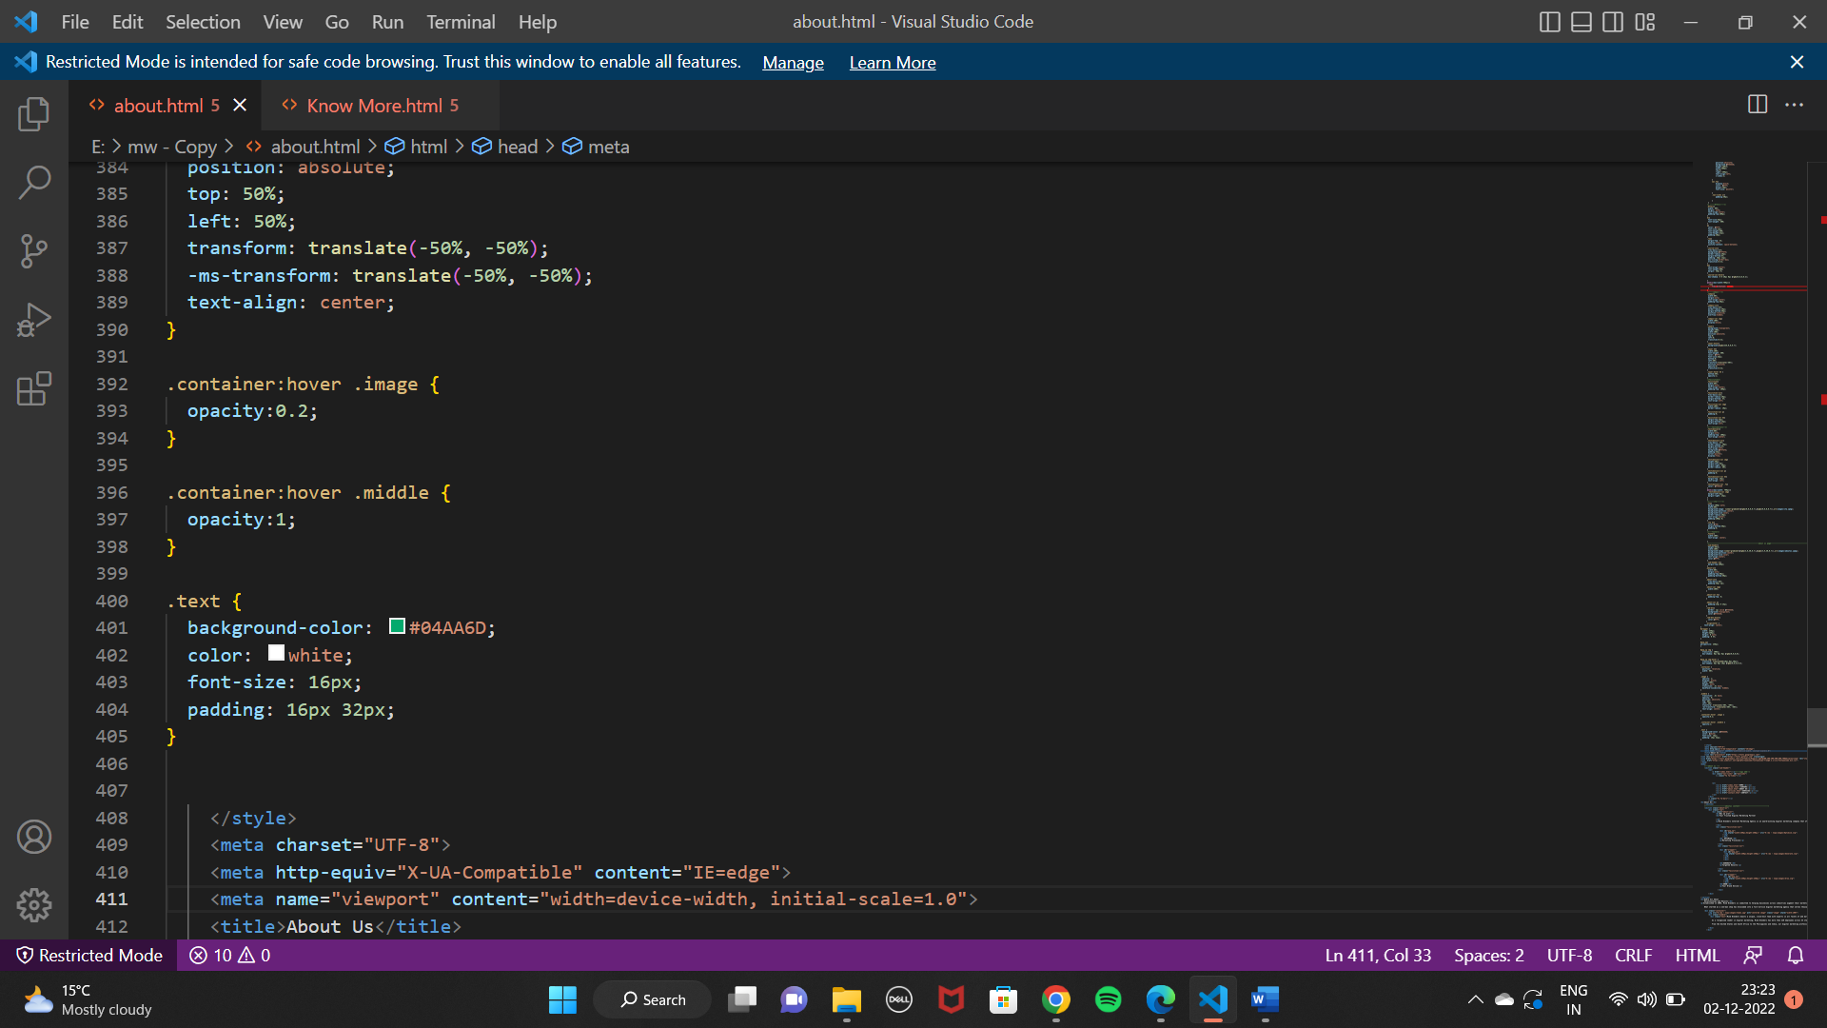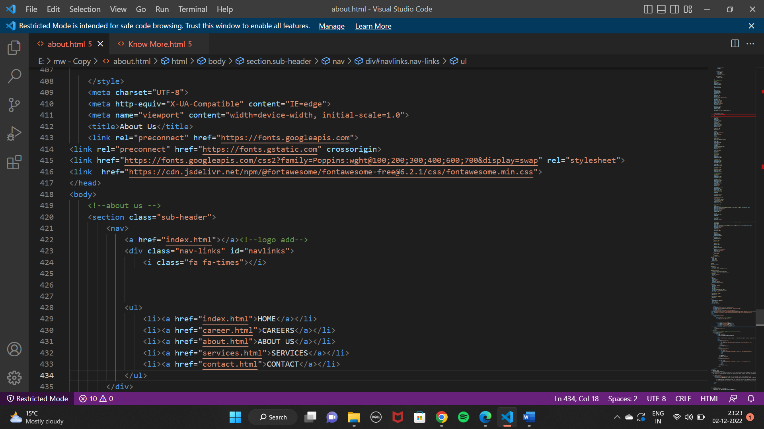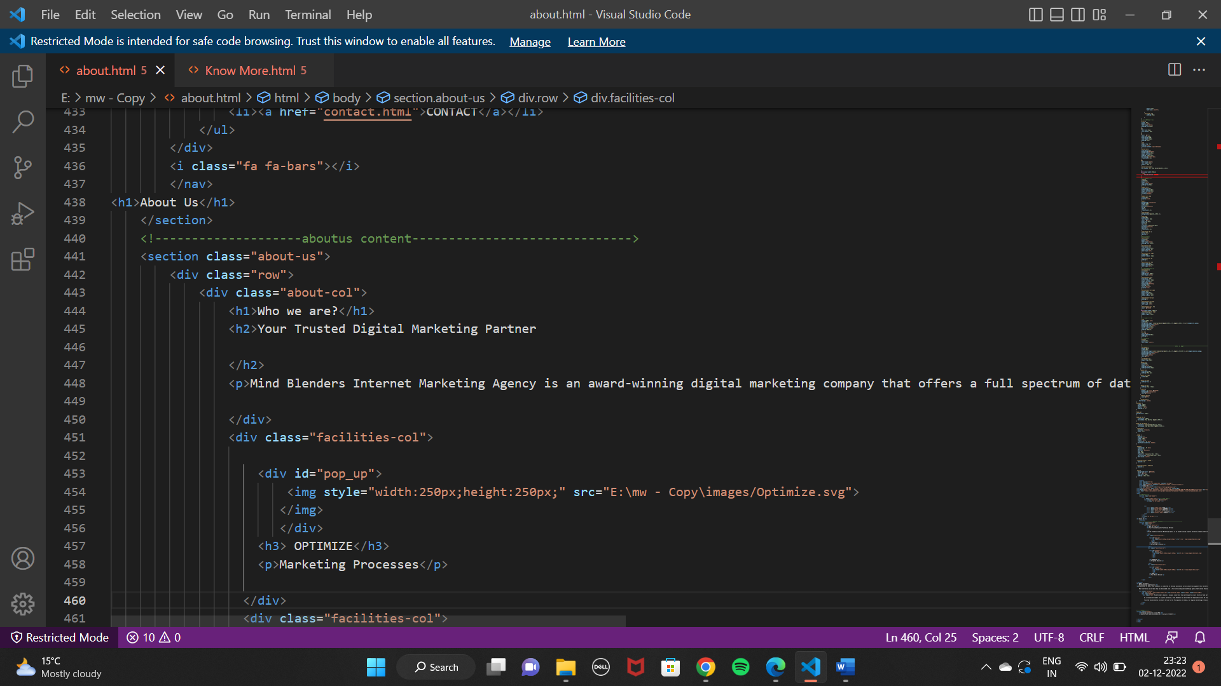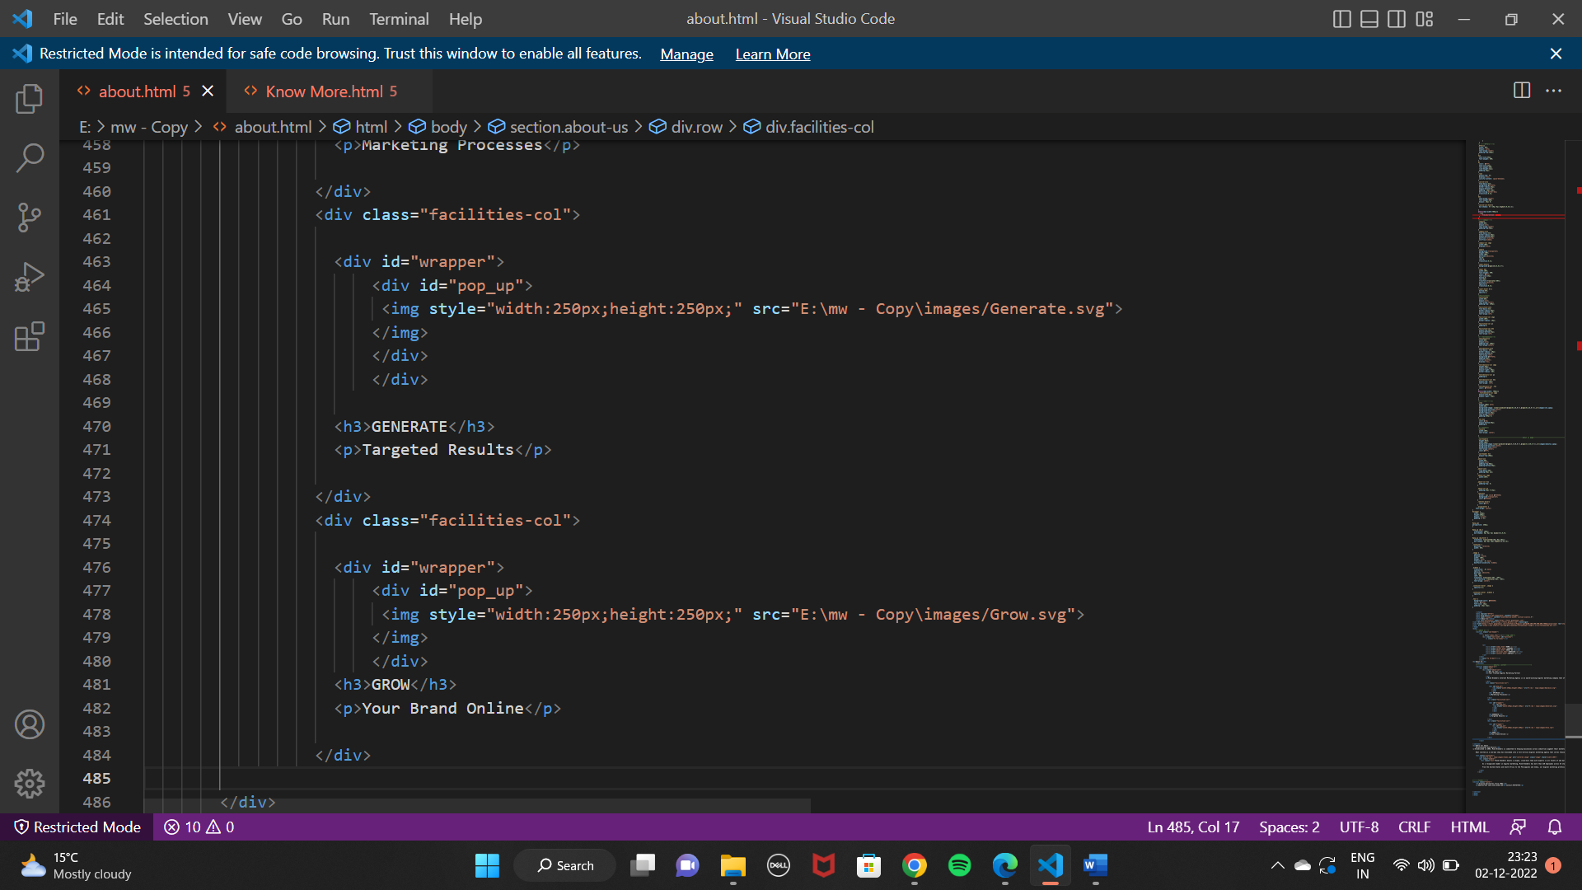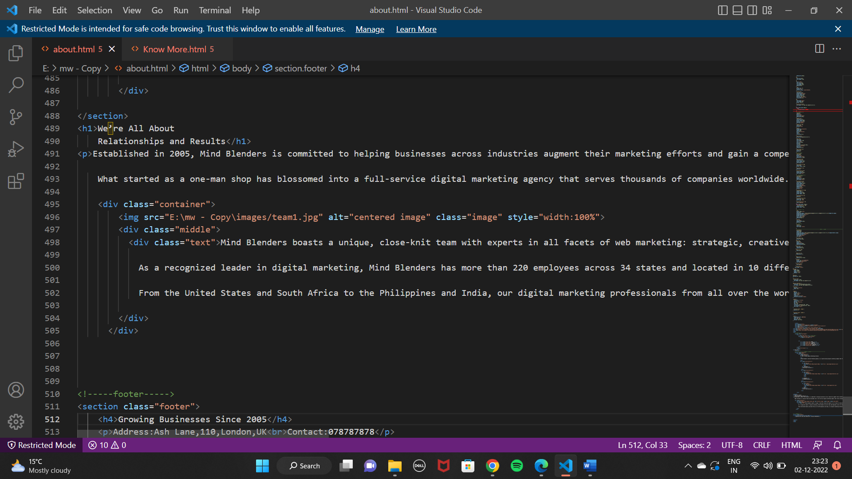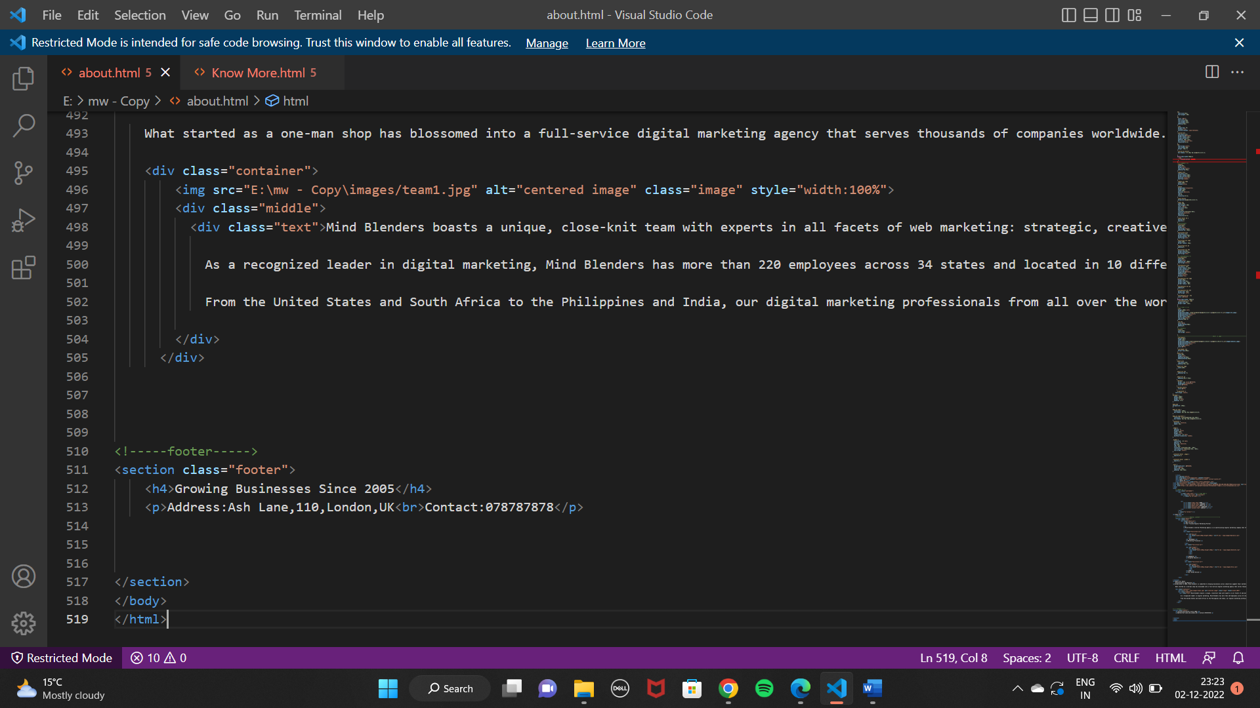

KNOW MORE(ACHIEVEMENTS) PAGE

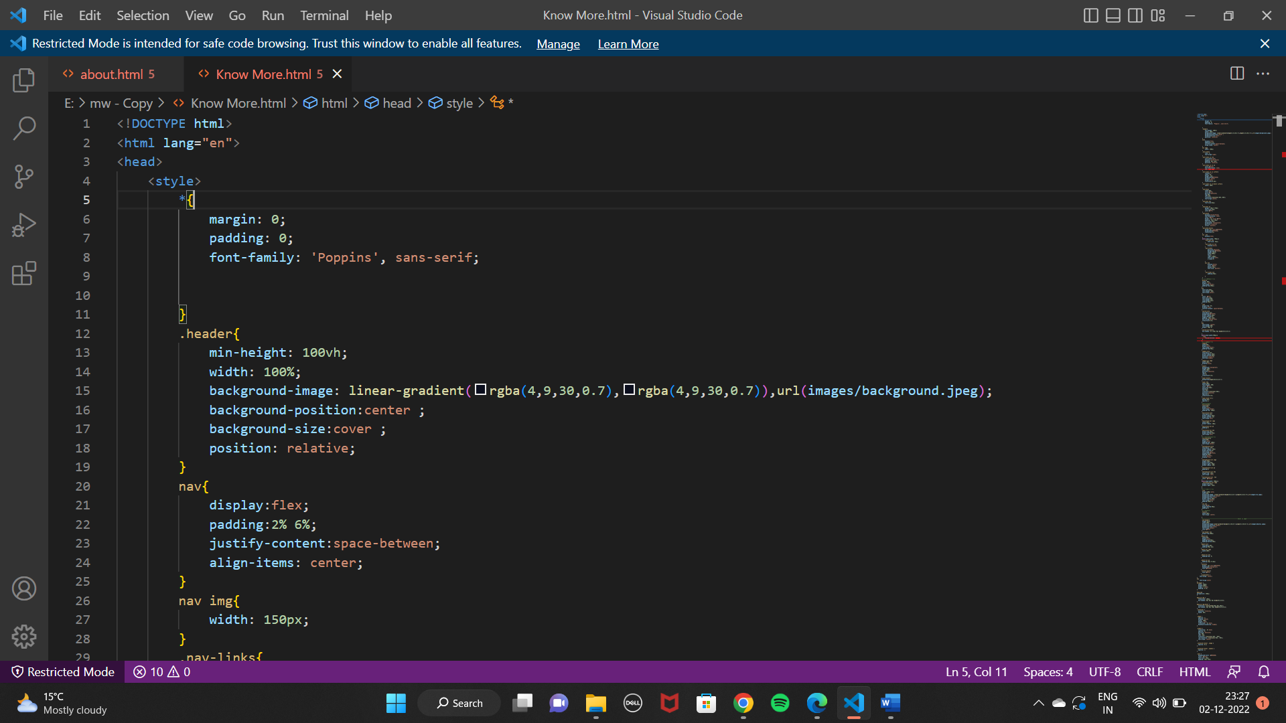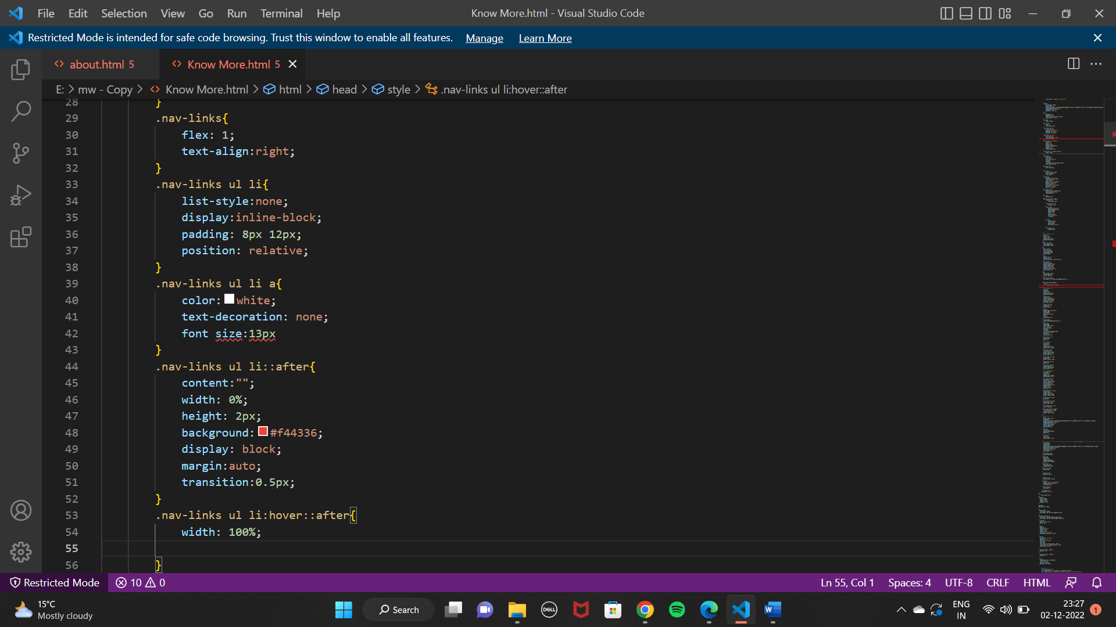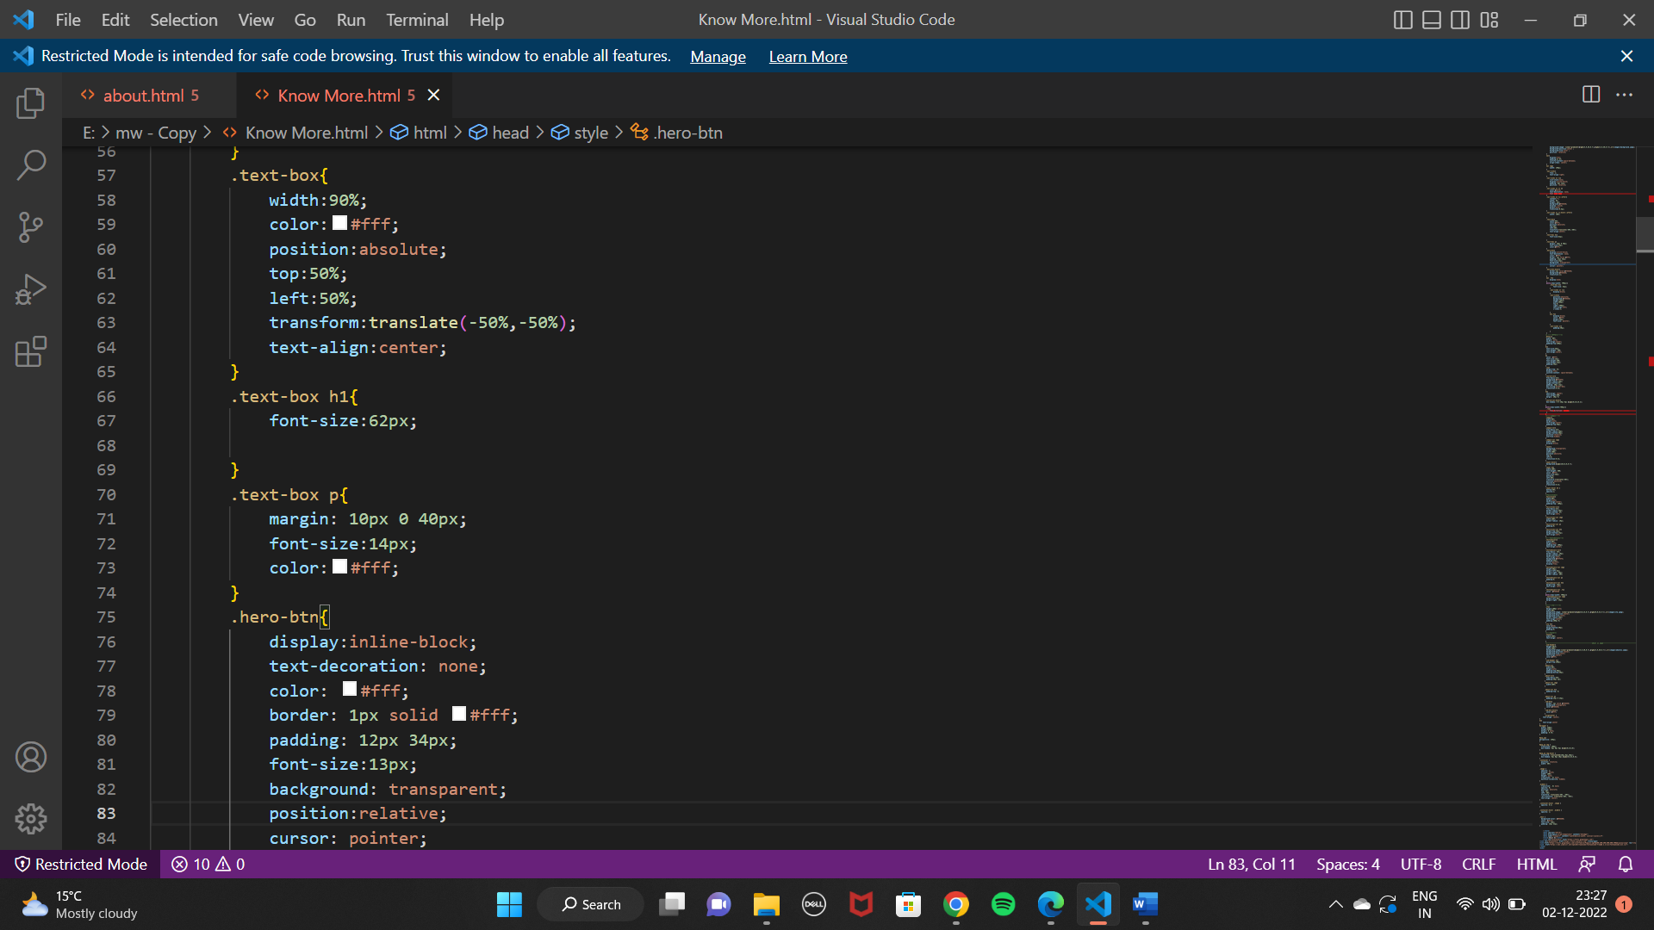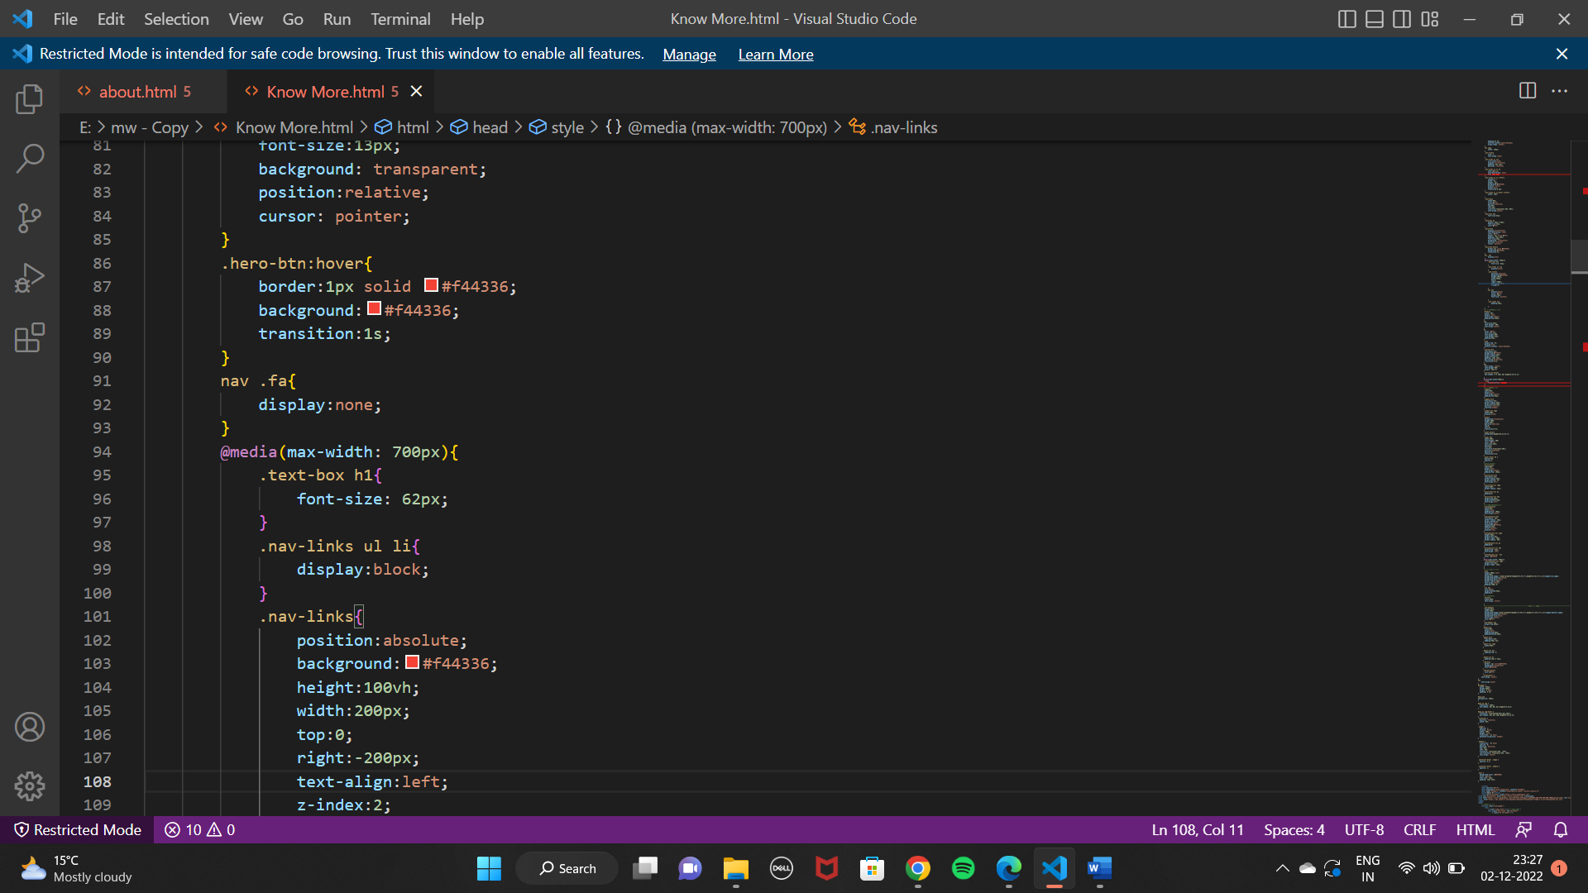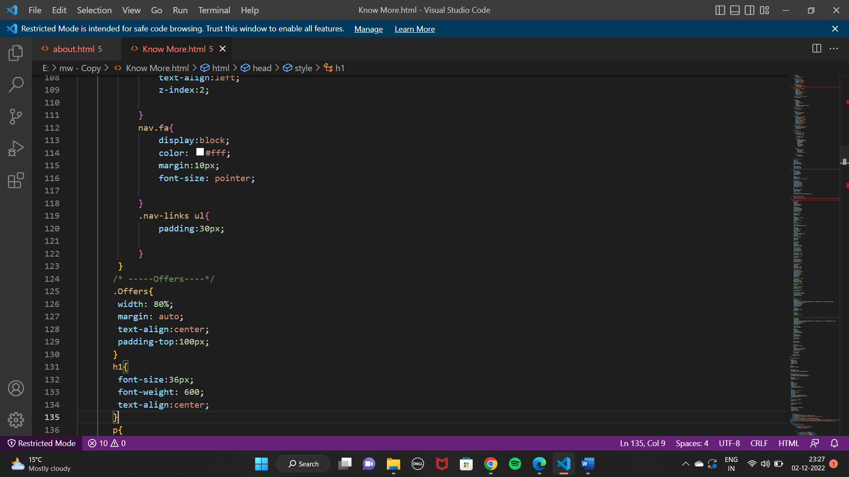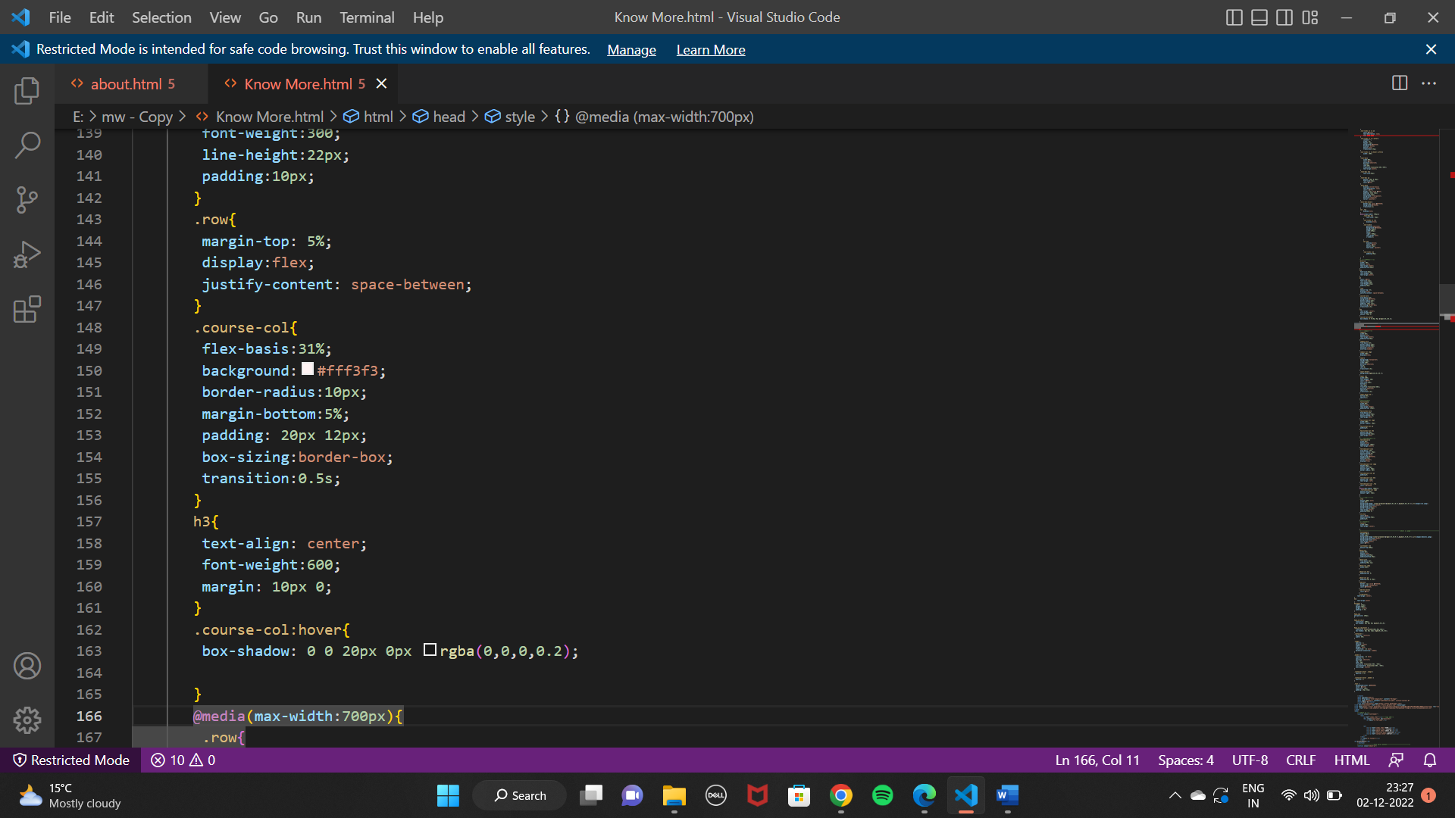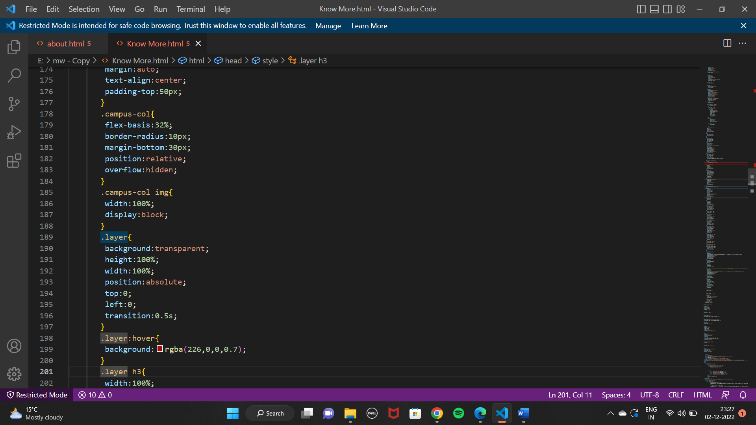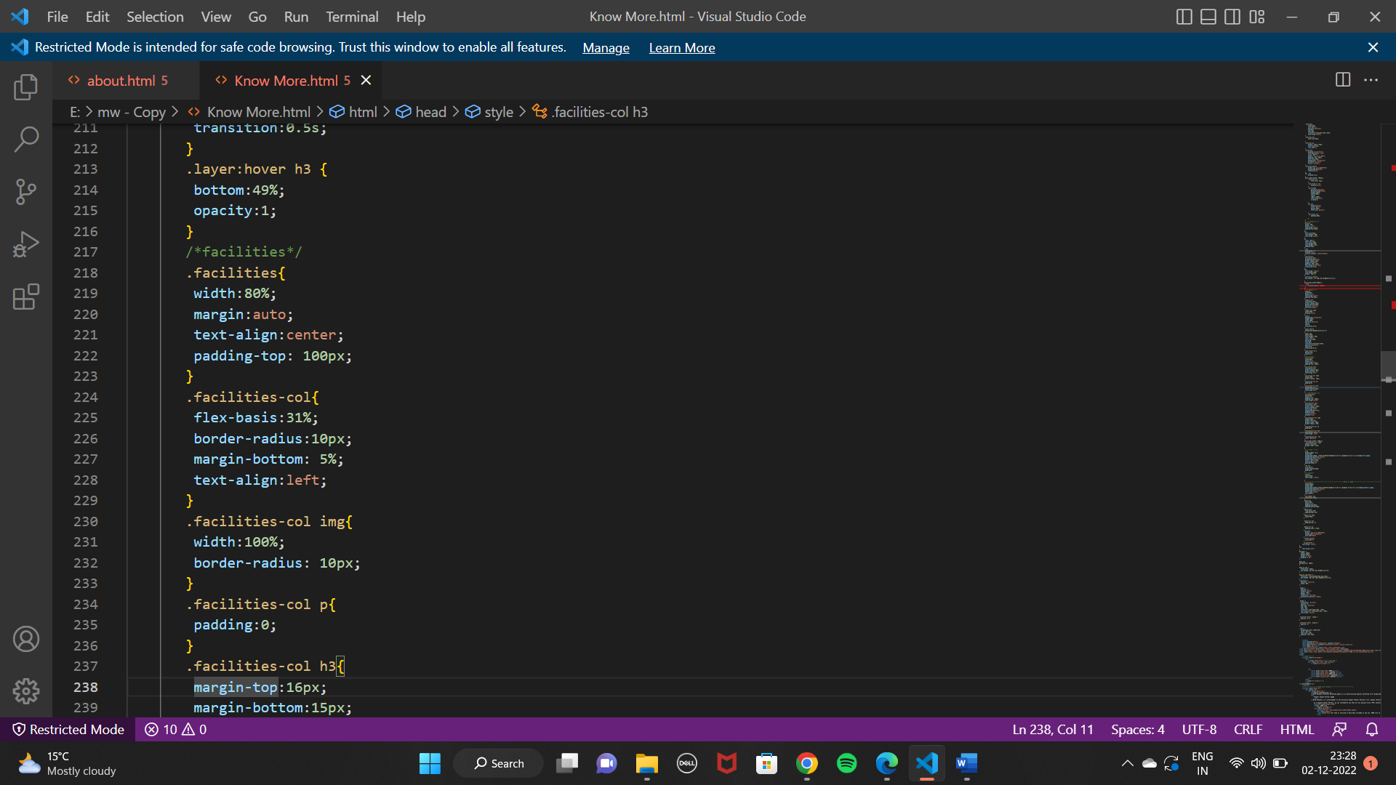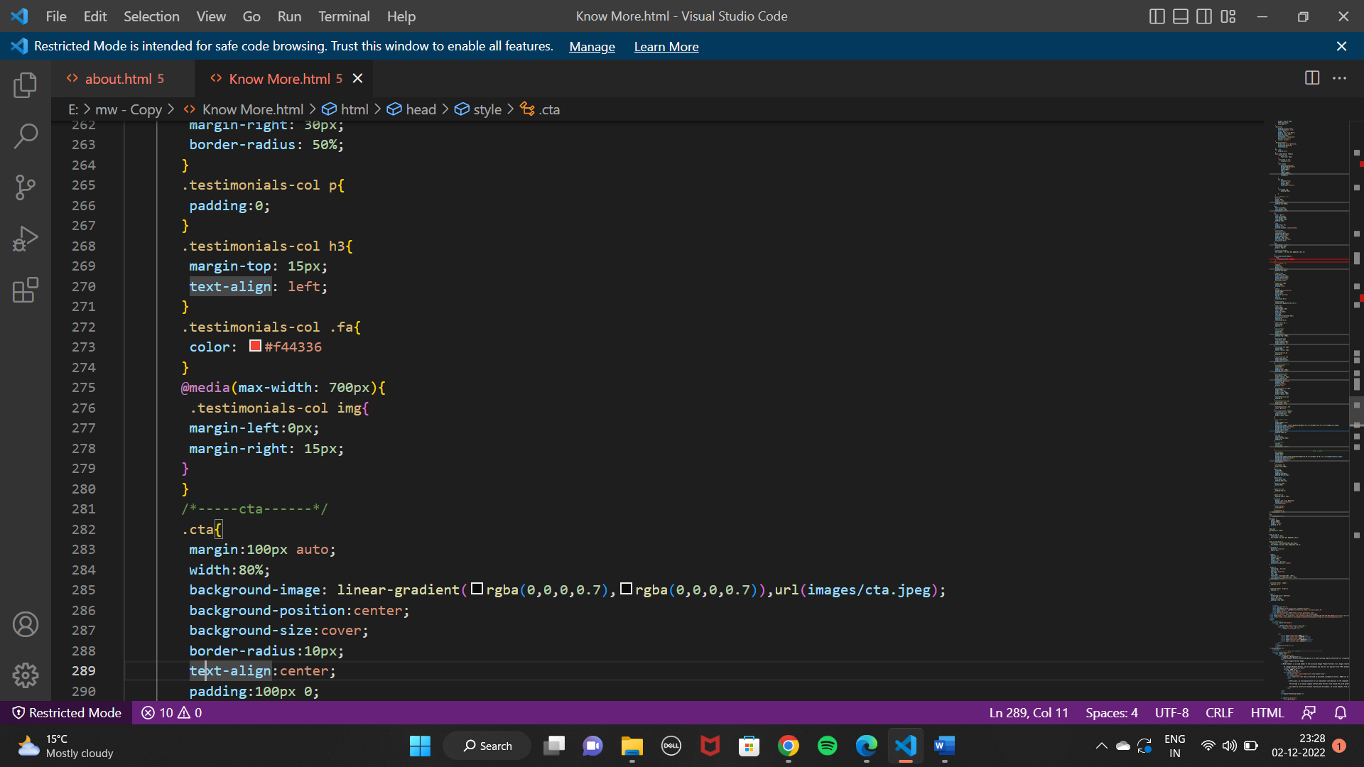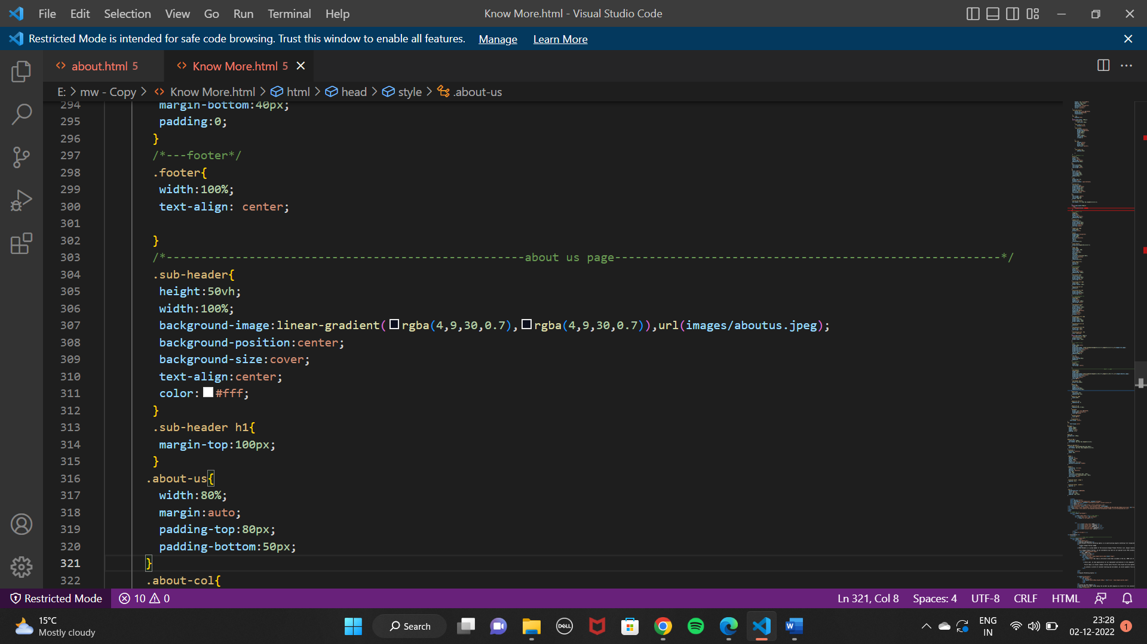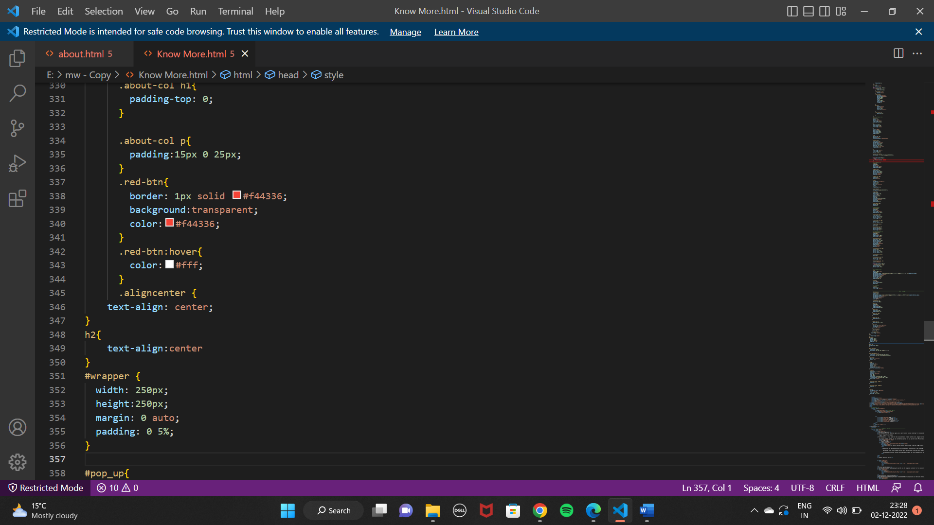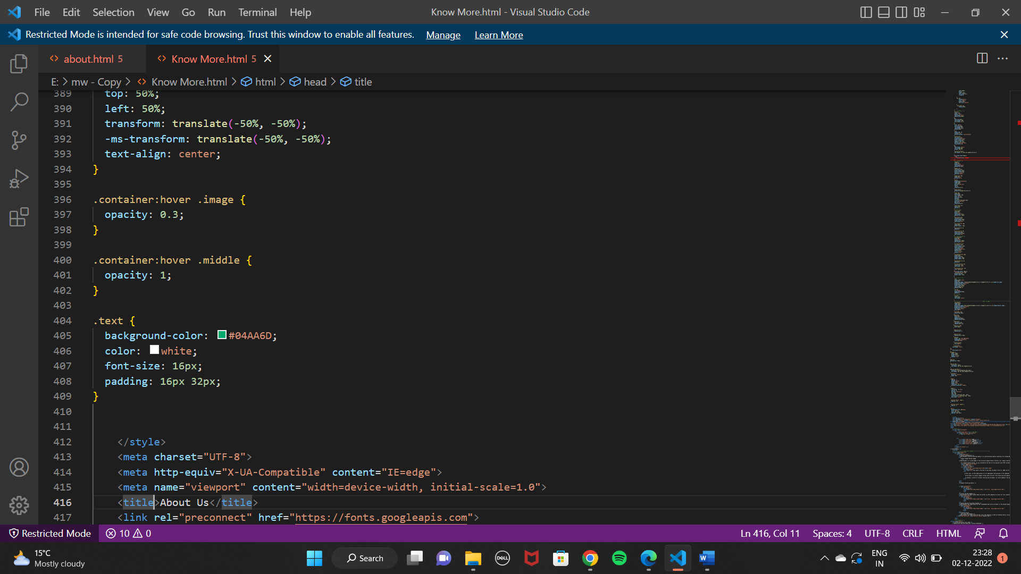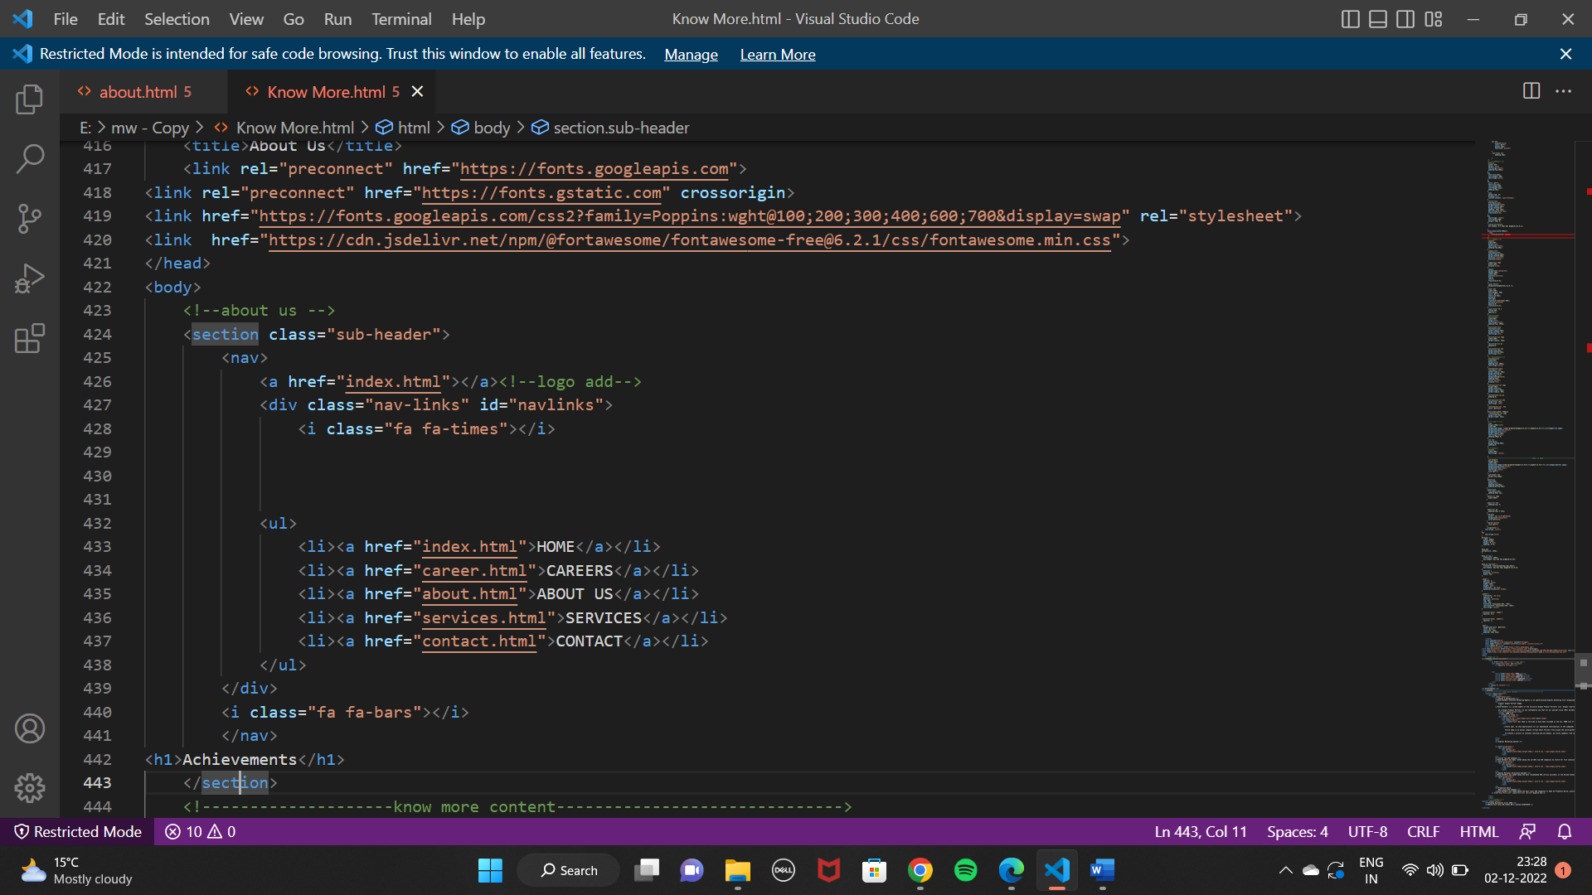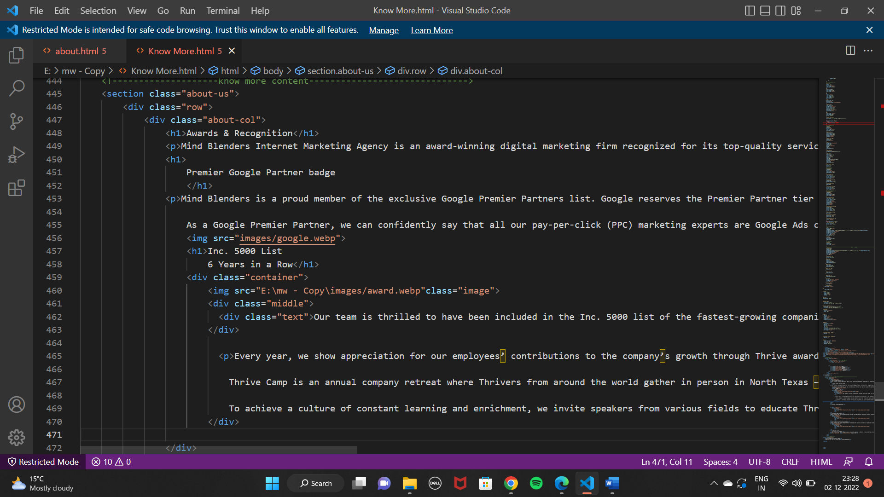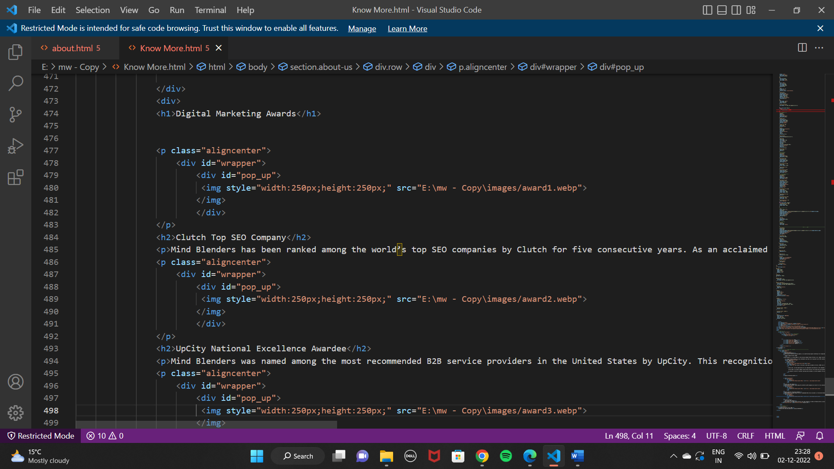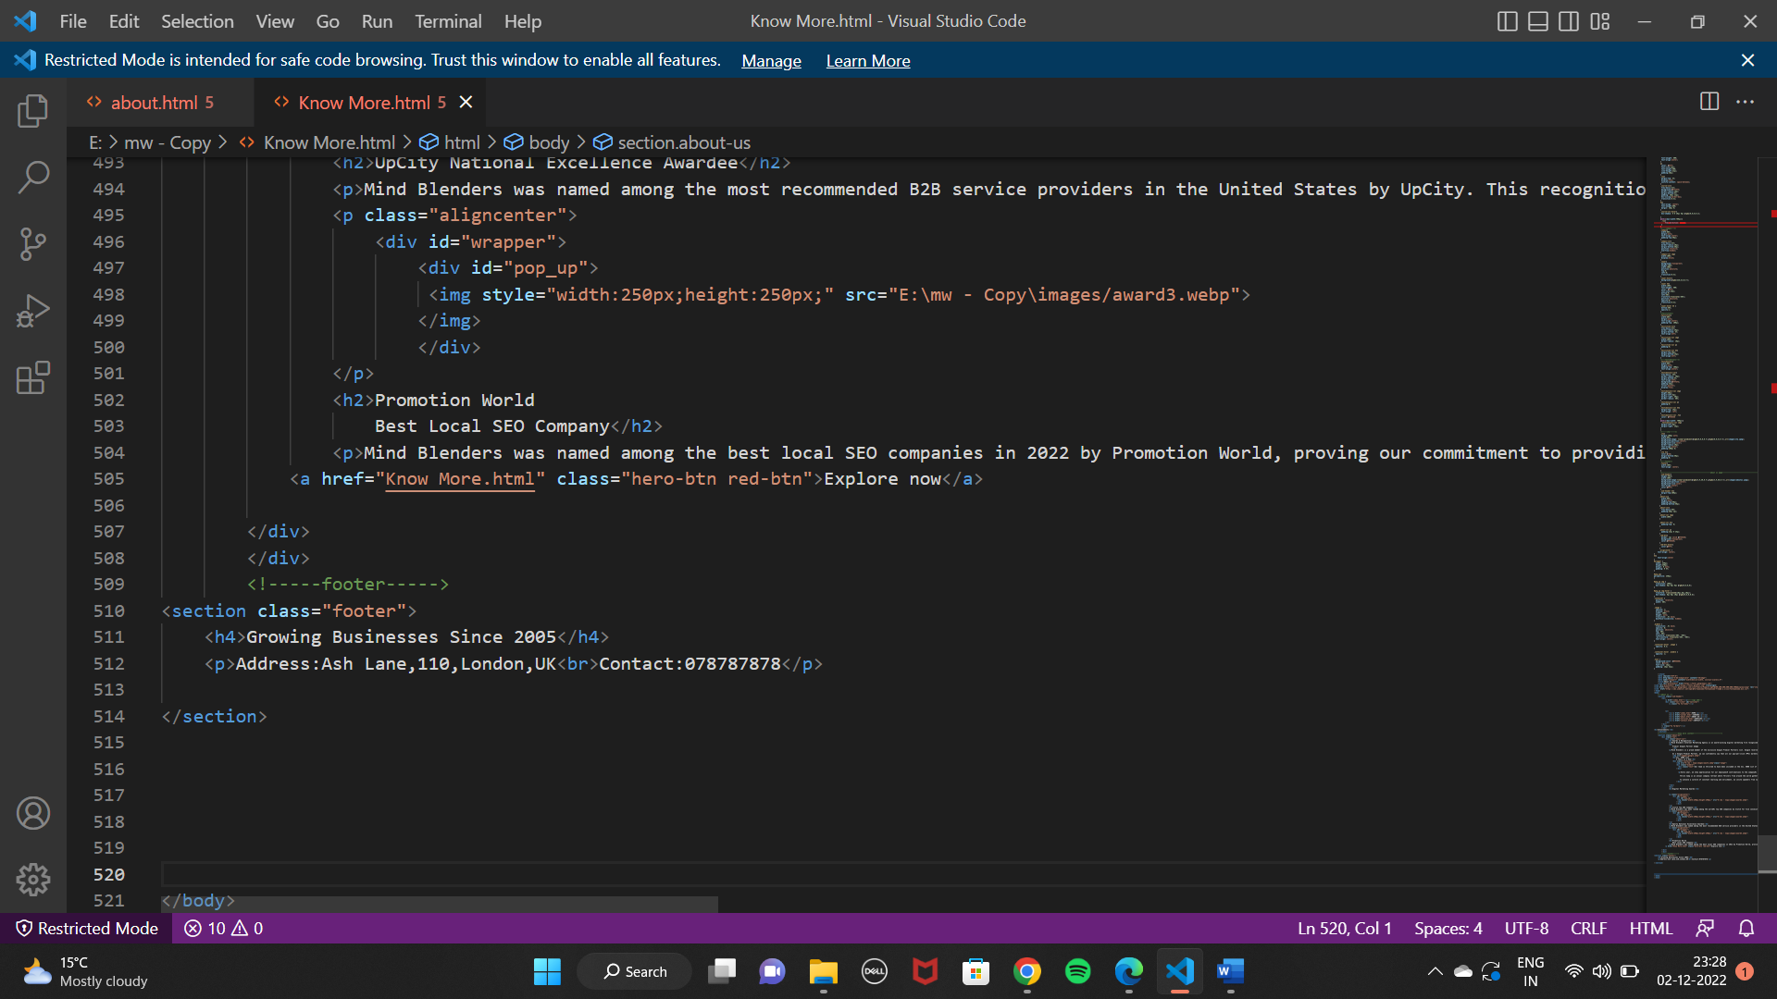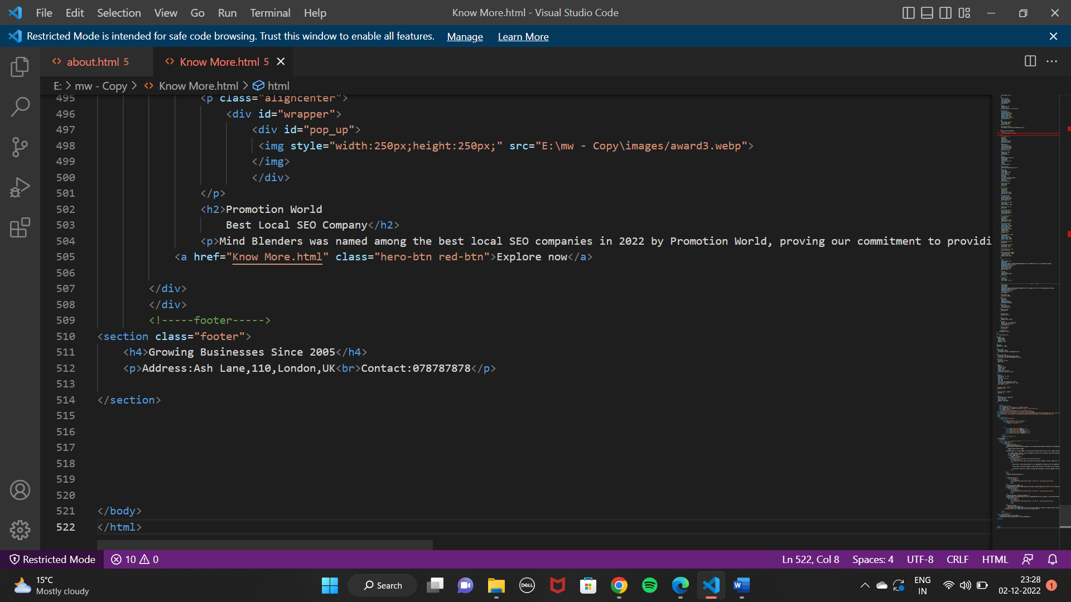

***SOURCE CODE***

ABOUT US PAGE

<!DOCTYPE html>

<html lang="en">

<head>

    <style>

        *{

            margin: 0;

            padding: 0;

            font-family: 'Poppins', sans-serif;

        }

        .header{

            min-height: 100vh;

            width: 100%;

            background-image: linear-gradient(rgba(4,9,30,0.7),rgba(4,9,30,0.7)),url(images/background.jpeg);

            background-position:center ;

            background-size:cover ;

            position: relative;

        }

        nav{

            display:flex;

            padding:2% 6%;

            justify-content:space-between;

            align-items: center;

        }

        nav img{

            width: 300px;

        }

        .nav-links{

            flex: 1;

            text-align:right;

        }

        .nav-links ul li{

            list-style:none;

            display:inline-block;

            padding: 8px 12px;

            position: relative;

        }

        .nav-links ul li a{

            color:white;

            text-decoration: none;

            font size:13px

        }

        .nav-links ul li::after{

            content:"";

            width: 0%;

            height: 2px;

            background:#f44336;

            display: block;

            margin:auto;

            transition:0.5px;

        }

        .nav-links ul li:hover::after{

            width: 100%;

        }

        .text-box{

            width:90%;

            color:#fff;

            position:absolute;

            top:50%;

            left:50%;

            transform:translate(-50%,-50%);

            text-align:center;

        }

        .text-box h1{

            font-size:62px;

        }

        .text-box p{

            margin: 10px 0 40px;

            font-size:14px;

            color:#fff;

        }

        .hero-btn{

            display:inline-block;

            text-decoration: none;

            color: #fff;

            border: 1px solid #fff;

            padding: 12px 34px;

            font-size:13px;

            background: transparent;

            position:relative;

            cursor: pointer;

        }

        .hero-btn:hover{

            border:1px solid #f44336;

            background:#f44336;

            transition:1s;

        }

        nav .fa{

            display:none;

        }

        @media(max-width: 700px){

            .text-box h1{

                font-size: 62px;

            }

            .nav-links ul li{

                display:block;

            }

            .nav-links{

                position:absolute;

                background:#f44336;

                height:100vh;

                width:200px;

                top:0;

                right:-200px;

                text-align:left;

                z-index:2;

            }

            nav.fa{

                display:block;

                color: #fff;

                margin:10px;

                font-size: pointer;

            }

            .nav-links ul{

                padding:30px;

            }

        }

       /* -----Offers----*/

       .Offers{

        width: 80%;

        margin: auto;

        text-align:center;

        padding-top:100px;

       }

       h1{

        font-size:36px;

        font-weight: 600;

       }

       p{

        color: #777;

        font-size:14px;

        font-weight:300;

        line-height:22px;

        padding:10px;

       }

       .row{

        margin-top: 5%;

        display:flex;

        justify-content: space-between;

       }

       .course-col{

        flex-basis:31%;

        background:#fff3f3;

        border-radius:10px;

        margin-bottom:5%;

        padding: 20px 12px;

        box-sizing:border-box;

        transition:0.5s;

       }

       h3{

        text-align:center;

        font-weight:600;

        margin: 10px 0;

       }

       .course-col:hover{

        box-shadow: 0 0 20px 0px rgba(0,0,0,0.2);

       }

       @media(max-width:700px){

        .row{

            flex.direction: column;

        }

       }

       /*----campus---*/

       .campus{

        width:80%;

        margin:auto;

        text-align:center;

        padding-top:50px;

       }

       .campus-col{

        flex-basis:32%;

        border-radius:10px;

        margin-bottom:30px;

        position:relative;

        overflow:hidden;

       }

       .campus-col img{

        width:100%;

        display:block;

       }

       .layer{

        background:transparent;

        height:100%;

        width:100%;

        position:absolute;

        top:0;

        left:0;

        transition:0.5s;

       }

       .layer:hover{

        background:rgba(226,0,0,0.7);

       }

       .layer h3{

        width:100%;

        font-weight: 500;

        color: #fff;

        font-size:26px;

        bottom:0;

        left:50%;

        transform:translate(-50%);

        position:absolute;

        opacity:0;

        transition:0.5s;

       }

       .layer:hover h3 {

        bottom:49%;

        opacity:1;

       }

       /*facilities*/

       .facilities{

        width:80%;

        margin:auto;

        text-align:center;

        padding-top: 100px;

       }

       .facilities-col{

        flex-basis:31%;

        border-radius:10px;

        margin-bottom: 5%;

        text-align:left;

       }

       .facilities-col img{

        width:100%;

        border-radius: 10px;

       }

       .facilities-col p{

        padding:0;

       }

       .facilities-col h3{

        margin-top:16px;

        margin-bottom:15px;

        text-align:left;

       }

       /*---testimonials--*/

       .testimonials{

        width:80%;

        margin:auto;

        padding-top: 100px;

        text-align:center;

       }

       .testimonials-col{

        flex-basis: 44%;

        border-radius: 10px;

        margin-bottom:5%;

        text-align:left;

        background:#fff3f3;

        padding:25px;

        cursor:pointer;

        display:flex;

       }

       .testimonials-col img{

        height:40px;

        margin-left:5px;

        margin-right: 30px;

        border-radius: 50%;

       }

       .testimonials-col p{

        padding:0;

       }

       .testimonials-col h3{

        margin-top: 15px;

        text-align: left;

       }

       .testimonials-col .fa{

        color: #f44336

       }

       @media(max-width: 700px){

        .testimonials-col img{

        margin-left:0px;

        margin-right: 15px;

       }

       }

       /*-----cta------*/

       .cta{

        margin:100px auto;

        width:80%;

        background-image: linear-gradient(rgba(0,0,0,0.7),rgba(0,0,0,0.7)),url(images/cta.jpeg);

        background-position:center;

        background-size:cover;

        border-radius:10px;

        text-align:center;

        padding:100px 0;

       }

       .cta h1{

        color:red;

        margin-bottom:40px;

        padding:0;

       }

       /*---footer*/

       .footer{

        width:100%;

        text-align: center;

       }

       /*----------------------------------------------------about us page--------------------------------------------------------*/

       .sub-header{

        height:50vh;

        width:100%;

        background-image:linear-gradient(rgba(4,9,30,0.7),rgba(4,9,30,0.7)),url(images/aboutus.jpeg);

        background-position:center;

        background-size:cover;

        text-align:center;

        color:#fff;

       }

       .sub-header h1{

        margin-top:100px;

       }

      .about-us{

        width:80%;

        margin:auto;

        padding-top:80px;

        padding-bottom:50px;

      }

      .about-col{

        flex-basis:48%;

        padding:30px 2px;

      }

      .about-col img{

        width:100%;

      }

      .about-col h1{

        padding-top: 0;

      }

      .about-col p{

        padding:15px 0 25px;

      }

      .red-btn{

        border: 1px solid #f44336;

        background:transparent;

        color:#f44336;

      }

      .red-btn:hover{

        color:#fff;

      }

      .aligncenter {

    text-align: center;

}

#wrapper {

  width: 250px;

  height:250px;

  margin: 0 auto;

  padding: 0 5%;

}

#pop_up{

perspective: 250px;

}

#pop_up img {

  transition: 100ms;

  box-shadow: 0px 0px 0px rgba(0,0,0,0);

}

#pop_up img:hover {

  transform: translate3d(10px,0px,20px);

  box-shadow: 0px 0px 10px rgba(0,0,0,0.8);

}

.container {

  position: relative;

  width: 50%;

}

.image {

  opacity: 1;

  display: block;

  width: 100%;

  height: auto;

  transition: .5s ease;

  backface-visibility: hidden;

}

.middle {

  transition: .5s ease;

  opacity: 0;

  position: absolute;

  top: 50%;

  left: 50%;

  transform: translate(-50%, -50%);

  -ms-transform: translate(-50%, -50%);

  text-align: center;

}

.container:hover .image {

  opacity:0.2;

}

.container:hover .middle {

  opacity:1;

}

.text {

  background-color: #04AA6D;

  color: white;

  font-size: 16px;

  padding: 16px 32px;

}

    </style>

    <meta charset="UTF-8">

    <meta http-equiv="X-UA-Compatible" content="IE=edge">

    <meta name="viewport" content="width=device-width, initial-scale=1.0">

    <title>About Us</title>

    <link rel="preconnect" href="https://fonts.googleapis.com">

<link rel="preconnect" href="https://fonts.gstatic.com" crossorigin>

<link href="https://fonts.googleapis.com/css2?family=Poppins:wght@100;200;300;400;600;700&display=swap" rel="stylesheet">

<link  href="https://cdn.jsdelivr.net/npm/@fortawesome/fontawesome-free@6.2.1/css/fontawesome.min.css">

</head>

<body>

    <!--about us -->

    <section class="sub-header">

        <nav>

            <a href="index.html"></a><!--logo add-->

            <div class="nav-links" id="navlinks">

                <i class="fa fa-times"></i>

            <ul>

                <li><a href="index.html">HOME</a></li>

                <li><a href="career.html">CAREERS</a></li>

                <li><a href="about.html">ABOUT US</a></li>

                <li><a href="services.html">SERVICES</a></li>

                <li><a href="contact.html">CONTACT</a></li>

            </ul>

        </div>

        <i class="fa fa-bars"></i>

        </nav>

<h1>About Us</h1>

    </section>

    <!--------------------aboutus content------------------------------>

    <section class="about-us">

        <div class="row">

            <div class="about-col">

                <h1>Who we are?</h1>

                <h2>Your Trusted Digital Marketing Partner

                </h2>

                <p>Mind Blenders Internet Marketing Agency is an award-winning digital marketing company that offers a full spectrum of data-driven web marketing services. We develop growth-oriented online marketing campaigns that make a positive impact on businesses..</p>

                </div>

                <div class="facilities-col">

                    <div id="pop_up">

                        <img style="width:250px;height:250px;" src="E:\mw - Copy\images/Optimize.svg">

                       </img>

                       </div>

                    <h3> OPTIMIZE</h3>

                    <p>Marketing Processes</p>

                  </div>

                  <div class="facilities-col">

                    <div id="wrapper">

                        <div id="pop_up">

                         <img style="width:250px;height:250px;" src="E:\mw - Copy\images/Generate.svg">

                        </img>

                        </div>

                        </div>

                    <h3>GENERATE</h3>

                    <p>Targeted Results</p>

                  </div>

                  <div class="facilities-col">

                    <div id="wrapper">

                        <div id="pop_up">

                         <img style="width:250px;height:250px;" src="E:\mw - Copy\images/Grow.svg">

                        </img>

                        </div>

                    <h3>GROW</h3>

                    <p>Your Brand Online</p>

                  </div>

        </div>

</section>

<h1>We’re All About

    Relationships and Results</h1>

<p>Established in 2005, Mind Blenders is committed to helping businesses across industries augment their marketing efforts and gain a competitive edge through comprehensive digital marketing solutions.

    What started as a one-man shop has blossomed into a full-service digital marketing agency that serves thousands of companies worldwide. Today, we have thousands of active clients from Germany, Hong Kong and the United States who have entrusted their digital success to our team. We work with businesses of all sizes – from startups to large franchises – in most industries and niches.</p>

    <div class="container">

        <img src="E:\mw - Copy\images/team1.jpg" alt="centered image" class="image" style="width:100%">

        <div class="middle">

          <div class="text">Mind Blenders boasts a unique, close-knit team with experts in all facets of web marketing: strategic, creative and technical.

            As a recognized leader in digital marketing, Mind Blenders has more than 220 employees across 34 states and located in 10 different countries. We work closely together to ensure smooth campaign development and execution for all of our clients.

            From the United States and South Africa to the Philippines and India, our digital marketing professionals from all over the world offer unique skill sets and years of industry expertise. In every project we handle, you can trust us to deliver custom web solutions that meet your long-term strategic goals.</div>

        </div>

      </div>

<!-----footer----->

<section class="footer">

    <h4>Growing Businesses Since 2005</h4>

    <p>Address:Ash Lane,110,London,UK<br>Contact:078787878</p>

</section>

</body>

</html>

KNOW MORE(ACHIEVEMENTS) PAGE

<!DOCTYPE html>

<html lang="en">

<head>

    <style>

        *{

            margin: 0;

            padding: 0;

            font-family: 'Poppins', sans-serif;

        }

        .header{

            min-height: 100vh;

            width: 100%;

            background-image: linear-gradient(rgba(4,9,30,0.7),rgba(4,9,30,0.7)),url(images/background.jpeg);

            background-position:center ;

            background-size:cover ;

            position: relative;

        }

        nav{

            display:flex;

            padding:2% 6%;

            justify-content:space-between;

            align-items: center;

        }

        nav img{

            width: 150px;

        }

        .nav-links{

            flex: 1;

            text-align:right;

        }

        .nav-links ul li{

            list-style:none;

            display:inline-block;

            padding: 8px 12px;

            position: relative;

        }

        .nav-links ul li a{

            color:white;

            text-decoration: none;

            font size:13px

        }

        .nav-links ul li::after{

            content:"";

            width: 0%;

            height: 2px;

            background:#f44336;

            display: block;

            margin:auto;

            transition:0.5px;

        }

        .nav-links ul li:hover::after{

            width: 100%;

        }

        .text-box{

            width:90%;

            color:#fff;

            position:absolute;

            top:50%;

            left:50%;

            transform:translate(-50%,-50%);

            text-align:center;

        }

        .text-box h1{

            font-size:62px;

        }

        .text-box p{

            margin: 10px 0 40px;

            font-size:14px;

            color:#fff;

        }

        .hero-btn{

            display:inline-block;

            text-decoration: none;

            color: #fff;

            border: 1px solid #fff;

            padding: 12px 34px;

            font-size:13px;

            background: transparent;

            position:relative;

            cursor: pointer;

        }

        .hero-btn:hover{

            border:1px solid #f44336;

            background:#f44336;

            transition:1s;

        }

        nav .fa{

            display:none;

        }

        @media(max-width: 700px){

            .text-box h1{

                font-size: 62px;

            }

            .nav-links ul li{

                display:block;

            }

            .nav-links{

                position:absolute;

                background:#f44336;

                height:100vh;

                width:200px;

                top:0;

                right:-200px;

                text-align:left;

                z-index:2;

            }

            nav.fa{

                display:block;

                color: #fff;

                margin:10px;

                font-size: pointer;

            }

            .nav-links ul{

                padding:30px;

            }

        }

       /* -----Offers----*/

       .Offers{

        width: 80%;

        margin: auto;

        text-align:center;

        padding-top:100px;

       }

       h1{

        font-size:36px;

        font-weight: 600;

        text-align:center;

       }

       p{

        color: #777;

        font-size:14px;

        font-weight:300;

        line-height:22px;

        padding:10px;

       }

       .row{

        margin-top: 5%;

        display:flex;

        justify-content: space-between;

       }

       .course-col{

        flex-basis:31%;

        background:#fff3f3;

        border-radius:10px;

        margin-bottom:5%;

        padding: 20px 12px;

        box-sizing:border-box;

        transition:0.5s;

       }

       h3{

        text-align: center;

        font-weight:600;

        margin: 10px 0;

       }

       .course-col:hover{

        box-shadow: 0 0 20px 0px rgba(0,0,0,0.2);

       }

       @media(max-width:700px){

        .row{

            flex.direction: column;

        }

       }

       /*----campus---*/

       .campus{

        width:80%;

        margin:auto;

        text-align:center;

        padding-top:50px;

       }

       .campus-col{

        flex-basis:32%;

        border-radius:10px;

        margin-bottom:30px;

        position:relative;

        overflow:hidden;

       }

       .campus-col img{

        width:100%;

        display:block;

       }

       .layer{

        background:transparent;

        height:100%;

        width:100%;

        position:absolute;

        top:0;

        left:0;

        transition:0.5s;

       }

       .layer:hover{

        background:rgba(226,0,0,0.7);

       }

       .layer h3{

        width:100%;

        font-weight: 500;

        color: #fff;

        font-size:26px;

        bottom:0;

        left:50%;

        transform:translate(-50%);

        position:absolute;

        opacity:0;

        transition:0.5s;

       }

       .layer:hover h3 {

        bottom:49%;

        opacity:1;

       }

       /*facilities*/

       .facilities{

        width:80%;

        margin:auto;

        text-align:center;

        padding-top: 100px;

       }

       .facilities-col{

        flex-basis:31%;

        border-radius:10px;

        margin-bottom: 5%;

        text-align:left;

       }

       .facilities-col img{

        width:100%;

        border-radius: 10px;

       }

       .facilities-col p{

        padding:0;

       }

       .facilities-col h3{

        margin-top:16px;

        margin-bottom:15px;

        text-align:left;

       }

       /*---testimonials--*/

       .testimonials{

        width:80%;

        margin:auto;

        padding-top: 100px;

        text-align:center;

       }

       .testimonials-col{

        flex-basis: 44%;

        border-radius: 10px;

        margin-bottom:5%;

        text-align:left;

        background:#fff3f3;

        padding:25px;

        cursor:pointer;

        display:flex;

       }

       .testimonials-col img{

        height:40px;

        margin-left:5px;

        margin-right: 30px;

        border-radius: 50%;

       }

       .testimonials-col p{

        padding:0;

       }

       .testimonials-col h3{

        margin-top: 15px;

        text-align: left;

       }

       .testimonials-col .fa{

        color: #f44336

       }

       @media(max-width: 700px){

        .testimonials-col img{

        margin-left:0px;

        margin-right: 15px;

       }

       }

       /*-----cta------*/

       .cta{

        margin:100px auto;

        width:80%;

        background-image: linear-gradient(rgba(0,0,0,0.7),rgba(0,0,0,0.7)),url(images/cta.jpeg);

        background-position:center;

        background-size:cover;

        border-radius:10px;

        text-align:center;

        padding:100px 0;

       }

       .cta h1{

        color:red;

        margin-bottom:40px;

        padding:0;

       }

       /*---footer*/

       .footer{

        width:100%;

        text-align: center;

       }

       /*----------------------------------------------------about us page--------------------------------------------------------*/

       .sub-header{

        height:50vh;

        width:100%;

        background-image:linear-gradient(rgba(4,9,30,0.7),rgba(4,9,30,0.7)),url(images/aboutus.jpeg);

        background-position:center;

        background-size:cover;

        text-align:center;

        color:#fff;

       }

       .sub-header h1{

        margin-top:100px;

       }

      .about-us{

        width:80%;

        margin:auto;

        padding-top:80px;

        padding-bottom:50px;

      }

      .about-col{

        flex-basis:48%;

        padding:30px 2px;

      }

      .about-col img{

        width:100%;

      }

      .about-col h1{

        padding-top: 0;

      }

      .about-col p{

        padding:15px 0 25px;

      }

      .red-btn{

        border: 1px solid #f44336;

        background:transparent;

        color:#f44336;

      }

      .red-btn:hover{

        color:#fff;

      }

      .aligncenter {

    text-align: center;

}

h2{

    text-align:center

}

#wrapper {

  width: 250px;

  height:250px;

  margin: 0 auto;

  padding: 0 5%;

}

#pop_up{

perspective: 250px;

}

#pop_up img {

  transition: 100ms;

  box-shadow: 0px 0px 0px rgba(0,0,0,0);

}

#pop_up img:hover {

  transform: translate3d(10px,0px,20px);

  box-shadow: 0px 0px 10px rgba(0,0,0,0.8);

}

.container {

  position: relative;

  width: 50%;

}

.image {

  opacity: 1;

  display: block;

  width: 100%;

  height: auto;

  transition: .5s ease;

  backface-visibility: hidden;

}

.middle {

  transition: .5s ease;

  opacity: 0;

  position: absolute;

  top: 50%;

  left: 50%;

  transform: translate(-50%, -50%);

  -ms-transform: translate(-50%, -50%);

  text-align: center;

}

.container:hover .image {

  opacity: 0.3;

}

.container:hover .middle {

  opacity: 1;

}

.text {

  background-color: #04AA6D;

  color: white;

  font-size: 16px;

  padding: 16px 32px;

}

    </style>

    <meta charset="UTF-8">

    <meta http-equiv="X-UA-Compatible" content="IE=edge">

    <meta name="viewport" content="width=device-width, initial-scale=1.0">

    <title>About Us</title>

    <link rel="preconnect" href="https://fonts.googleapis.com">

<link rel="preconnect" href="https://fonts.gstatic.com" crossorigin>

<link href="https://fonts.googleapis.com/css2?family=Poppins:wght@100;200;300;400;600;700&display=swap" rel="stylesheet">

<link  href="https://cdn.jsdelivr.net/npm/@fortawesome/fontawesome-free@6.2.1/css/fontawesome.min.css">

</head>

<body>

    <!--about us -->

    <section class="sub-header">

        <nav>

            <a href="index.html"></a><!--logo add-->

            <div class="nav-links" id="navlinks">

                <i class="fa fa-times"></i>

            <ul>

                <li><a href="index.html">HOME</a></li>

                <li><a href="career.html">CAREERS</a></li>

                <li><a href="about.html">ABOUT US</a></li>

                <li><a href="services.html">SERVICES</a></li>

                <li><a href="contact.html">CONTACT</a></li>

            </ul>

        </div>

        <i class="fa fa-bars"></i>

        </nav>

<h1>Achievements</h1>

    </section>

    <!--------------------know more content------------------------------>

    <section class="about-us">

        <div class="row">

            <div class="about-col">

                <h1>Awards & Recognition</h1>

                <p>Mind Blenders Internet Marketing Agency is an award-winning digital marketing firm recognized for its top-quality service and technological expertise. With the accolades to back up our exemplary customer service, we take great pride in our operational excellence and industry-leading digital marketing solutions..</p>

                <h1>

                    Premier Google Partner badge

                    </h1>

                <p>Mind Blenders is a proud member of the exclusive Google Premier Partners list. Google reserves the Premier Partner tier for the top 3 percent of participating companies that demonstrate Google Ads skills and expertise.

                    As a Google Premier Partner, we can confidently say that all our pay-per-click (PPC) marketing experts are Google Ads certified. Partner with us and you’re entrusting your ad campaigns to proven PPC specialists who continuously meet Google’s certification, ad spend and performance requirements.</p>

                    <img src="images/google.webp">

                    <h1>Inc. 5000 List

                        6 Years in a Row</h1>

                    <div class="container">

                        <img src="E:\mw - Copy\images/award.webp"class="image">

                        <div class="middle">

                          <div class="text">Our team is thrilled to have been included in the Inc. 5000 list of the fastest-growing companies in America for the sixth consecutive year.</div>

                        </div>

                          <p>Every year, we show appreciation for our employees’ contributions to the company’s growth through Thrive awards presented during Thrive Camp.

                            Thrive Camp is an annual company retreat where Thrivers from around the world gather in person in North Texas – or virtually online during the coronavirus pandemic – and set aside time to celebrate our company, the strong work relationships we have built and the significant milestones and achievements we’ve accomplished throughout the year.

                            To achieve a culture of constant learning and enrichment, we invite speakers from various fields to educate Thrivers on best practices for personal and professional development. Thrive Camp is also the time for us to map out our goals and strategies for the year ahead to help us navigate the changes and ensure a successful new year.</p>

                        </div>

                </div>

                <div>

                <h1>Digital Marketing Awards</h1>

                <p class="aligncenter">

                    <div id="wrapper">

                        <div id="pop_up">

                         <img style="width:250px;height:250px;" src="E:\mw - Copy\images/award1.webp">

                        </img>

                        </div>

                </p>

                <h2>Clutch Top SEO Company</h2>

                <p>Mind Blenders has been ranked among the world’s top SEO companies by Clutch for five consecutive years. As an acclaimed SEO firm, we go above and beyond to position our clients to the top of search results using white-hat SEO services.</p>

                <p class="aligncenter">

                    <div id="wrapper">

                        <div id="pop_up">

                         <img style="width:250px;height:250px;" src="E:\mw - Copy\images/award2.webp">

                        </img>

                        </div>

                </p>

                <h2>UpCity National Excellence Awardee</h2>

                <p>Mind Blenders was named among the most recommended B2B service providers in the United States by UpCity. This recognition proves our commitment to providing unparalleled service to all our clients.</p>

                <p class="aligncenter">

                    <div id="wrapper">

                        <div id="pop_up">

                         <img style="width:250px;height:250px;" src="E:\mw - Copy\images/award3.webp">

                        </img>

                        </div>

                </p>

                <h2>Promotion World

                    Best Local SEO Company</h2>

                <p>Mind Blenders was named among the best local SEO companies in 2022 by Promotion World, proving our commitment to providing best-in-class local SEO services that propel brands and help them grow their business.</p>

            <a href="Know More.html" class="hero-btn red-btn">Explore now</a>

        </div>

        </div>

        <!-----footer----->

<section class="footer">

    <h4>Growing Businesses Since 2005</h4>

    <p>Address:Ash Lane,110,London,UK<br>Contact:078787878</p>

</section>

</body>

</html>

***OUTPUT***

ABOUT US PAGE

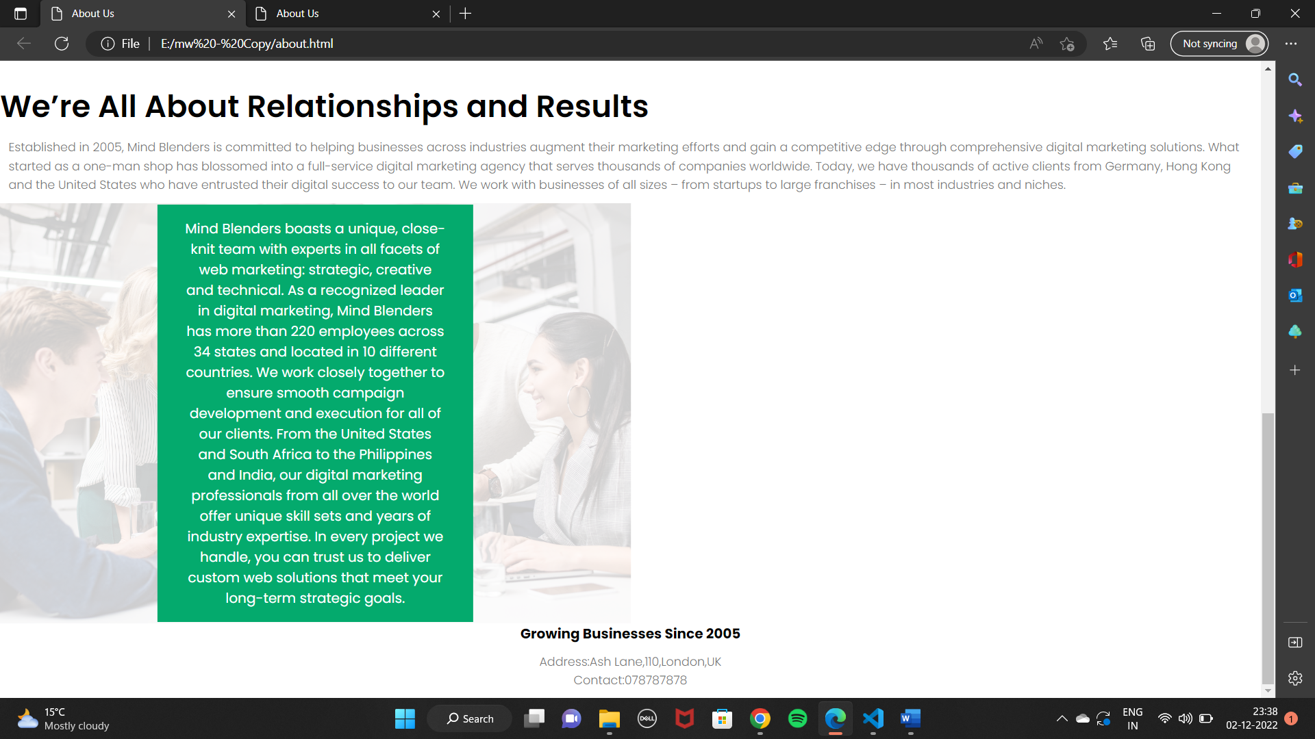

KNOW MORE(ACHIEVEMENTS) PAGE

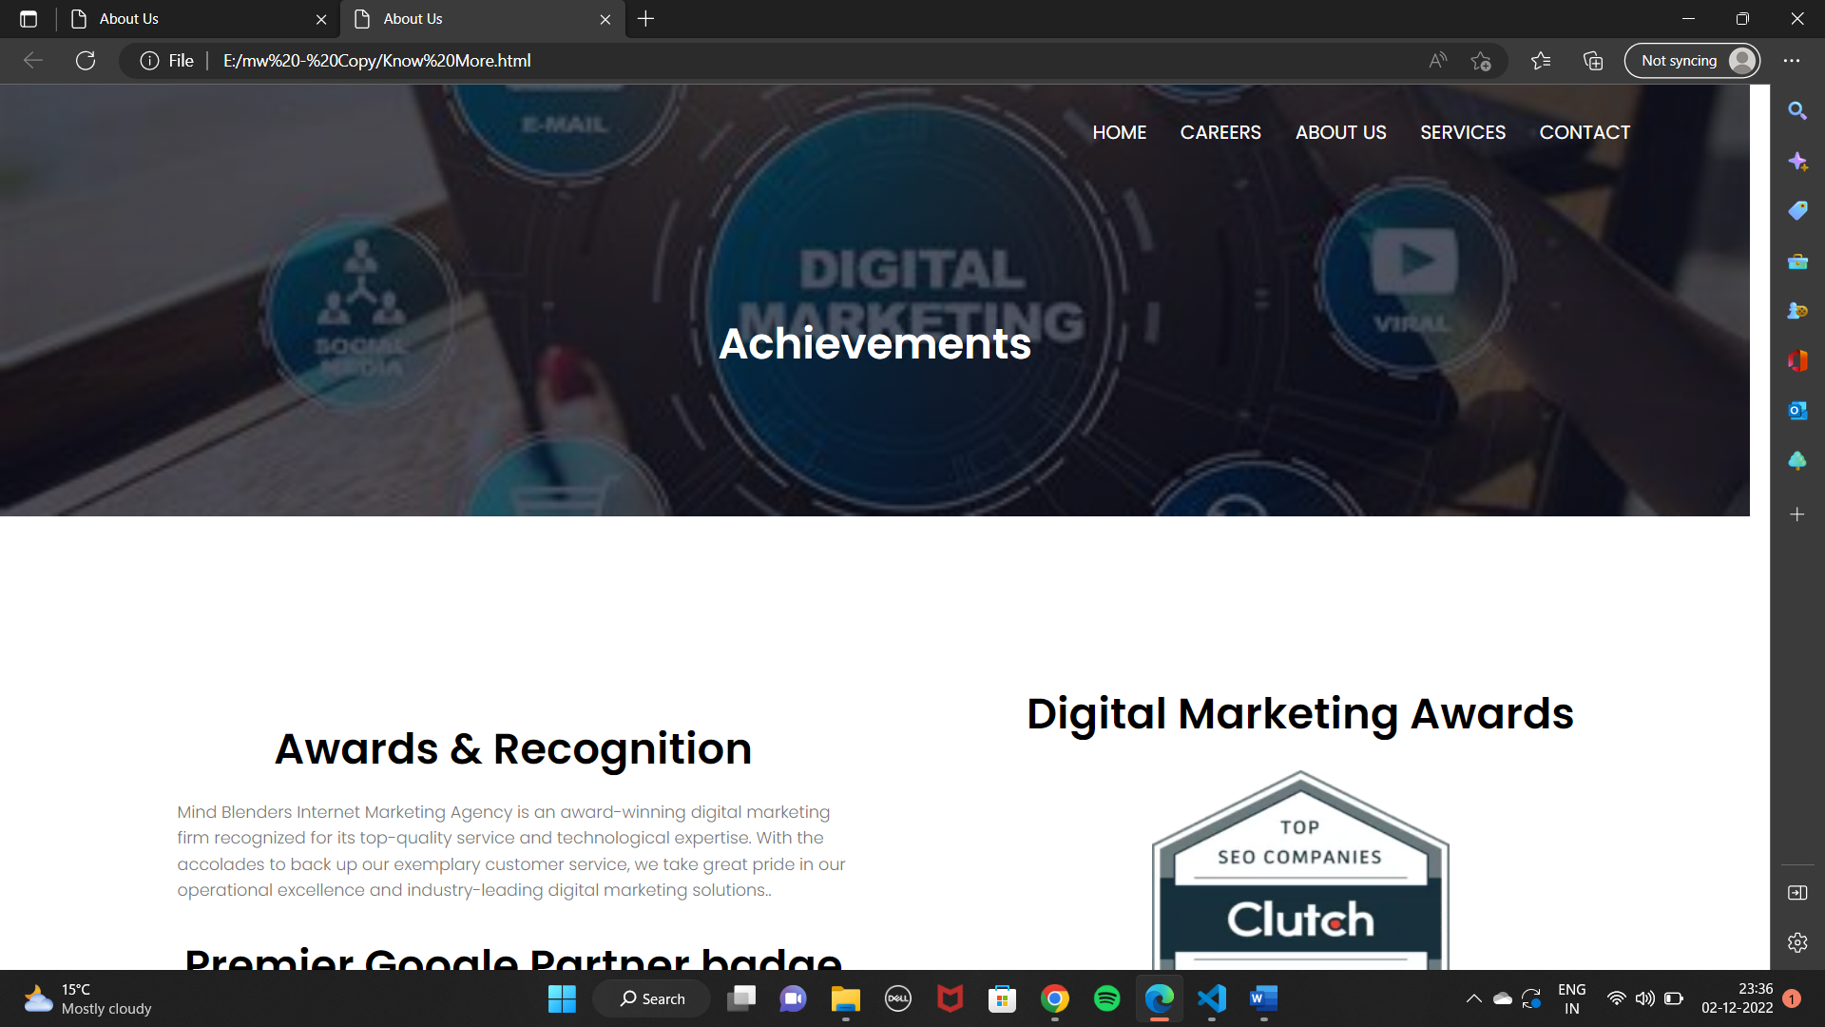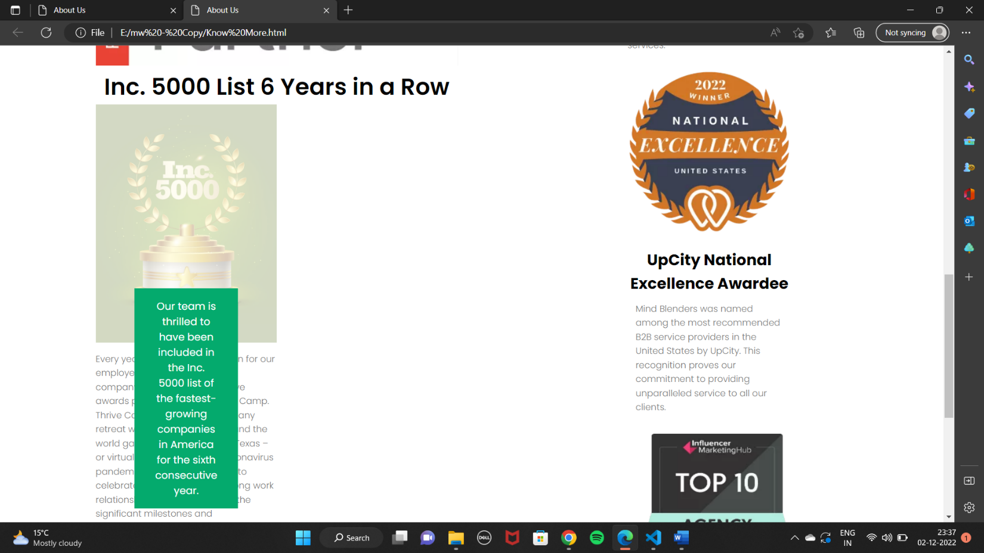

***CONCLUSION***

In today's Web development, a good page design is essential. A bad design will lead to the loss of visitors and that can lead to a loss of business. In general, a good page layout has to satisfy the basic elements of a good page design. This includes color contrast, text organization, font selection, style of a page, page size, graphics used, and consistency. In order to create a well-designed page for a specific audience. The developer needs to organized and analyze the users' statistics and the background of the users. Although it can be hard to come up with a design that is well suited to all of the users, there will be a design that is appropriate for most of the audience. The better the page design, the more hits a page will get. That implies an increase in accessibility and a possible increase in business.